2023

Created through support and resource from the Family and Juvenile Court Improvement Program.
Example Quarterly Report Template

HOW TO USE THIS TEMPLATE
- Review the Template: Familiarize yourself with the sections and headings.
- Gather Data: Using iDTR and/or Dependency Dash, collect the necessary data from your local dependency cases.
- Fill in the Template: Use the provided sections and prompts to input the collected data.
- Analyze the Data: Review the filled template to identify trends, patterns, and any potential issues.
- Compare with State Benchmarks: Compare your local performance against state benchmarks. Identify areas where your court is exceeding benchmarks and areas that may require attention.
- Share with Local Team: Communicate the results of the data analysis with your local team, highlighting progress, challenges, and areas for improvement. Encourage open discussions to collectively strategize solutions.
- Regular Review and Iteration: Use this template as part of a regular monitoring and reporting process.

County Dependency Data,

Suggestion: To begin your report, consider incorporating a statement that aligns with your purpose for engaging in system improvement work and fostering a learning community. This introductory statement can serve as a compelling opening for your report.

DEPENDENCY FILINGS
Sources of Data: Fact Finding Excel, DPP Filing -OROD Month sheet, Dep Graph sheet

Overview of what the data are telling you about the filings and children coming into your system.
Description Example: Figure 1 shows the number of dependency cases filed in Washington’s courts annually for children (ages 0-17) for the last six years. Since 2018, at 4,601, the number of dependency filings has been declining annually, reaching a historic low in 2022. The pace of decline accelerated during the COVID-19 pandemic (between 2019 and 2020), when the number of dependency petitions dropped 24% a year. The end of the pandemic, however, did not stop this decline. The number of dependency filings decreased from the prior year for both 2021 and 2022. The decrease observed from 2020 to 2021 was approximately 10% percent, and the decrease from 2021 to 2022 was 12%.

Create a similar graph for your court. When analyzing trends in dependency filings, it is important to take into consideration the local context and factors that may be contributing to variations in trends cross different regions in the state. Use the data to tell the court partners what is being learned through the data.

FIGURE 1: DEPENDENCY COURT FILINGS, BY YEAR FOR THE STATE
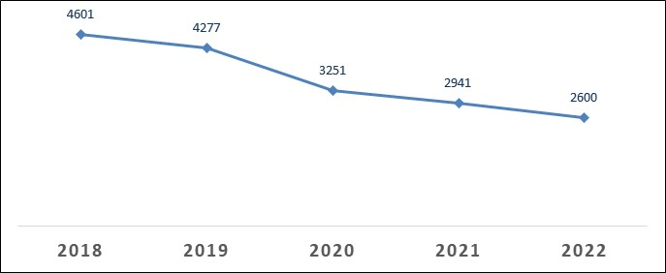

You can create graphs and charts specific to what you want to highlight and what story you want to tell. Some examples of what you can report are presented below: 1) Fillings broken out by quarter; 2) Fillings by designation, or 3) Fillings by DCYF office. The iDTR allows you to identify the office the filing was from.

DEMOGRAPHICS OF DEPENDENCY FILINGS
Analyzing demographics of your filings can help tell your story and understand the families in your system. For example, Figure 2 shows the number of dependency petitions for infants filed between 2017 and 2020.
Description Example: The analysis of statewide dependency filings by age reveals that cases involving infants (>1) consistently constituted the largest proportion of dependency filings each year since 2018. However, it is noteworthy that there has been a 35% decline in the number of filings involving infants between 2018 and 2022, from 1,277 to 832 (Figure 2).
Sources of Data: Fact Finding Excel, DPP Filing - OROD Month sheet, Dep Graph sheet, Perm Outcomes Excel
DEP Child Demo sheet, Dep Filing Rates by Race

FIGURE 2: DEPENDENCY COURT FILINGS INVOLVING INFANTS, BY YEAR

Description Example: In 2022, Washington's courts received a total of 832 dependency cases involving children aged 0-17, with infants comprising 34% of these cases (Figure 3). Additionally, when considering infants and toddlers together (ages 0-3), they accounted for 47% of all dependency filings.

FIGURE 3: 2022 DEPENDENCY FILINGS, BY AGE
How does this data look in your county?

You can choose to create graphs and charts that highlight the specific message you want to convey. Additionally, think about the narrative or story you intend the data to communicate. Some examples of what you can report are presented below: 1) Fillings broken out by age and 2) Fillings broken out by race.

Description Example 2: Changes in the distribution of dependency cases among different racial and ethnic groups:
- The number of filings involving Caucasian children decreased from 200 in 2010 to 124 in 2020.
- The number of filings involving Black children decreased from 160 in 2010 to 82 in 2020.
- The number of filings involving Hispanic children decreased from 89 in 2010 to 46 in 2020.

Relative Changes: in addition to the absolute numbers, you can calculate percentage changes to understand relative shifts over time.

.

Description Example 1: Dependency filings vary across different age groups (<1, 1-2 years old, 3-5 years old, 6-11 years old, 12-17 years old, and >17). Infants consistently account for the highest number of dependency petitions filed each year, although there has been a 17% decrease in petitions involving infants from 2017 to 2020.
For children aged 6-11 years, there was a 10% decline in filings between 2017 and 2019. This decline continued into 2020, likely due to the impact of the COVID-19 pandemic.
In addition to just telling how many times different races are involved in dependency filings, you can also show how often it happens compared to the total number of people in each racial or ethnic group. Graph below shows King’s fillings rates per 1,000 by race, 2010-2019.
Comparing the racial breakdown for your county helps you identify disproportionalities in your system. Regional variations in demographics can play a role in county-level variation in dependency filings. Counties with larger populations of specific racial and ethnic groups may have higher filing rates for those groups simply due to the greater number of children from those demographics residing in the county.
Description Example: In King County, American Indian/Alaska Native (AI/AN), Black, and multiracial children consistently had higher filing rates compared to White, Hispanic/Latino, Asian/PI children, and Multi-racial. From 2010 to 2016, AI/AN children had the highest filing rates. Since 2017, Black children had either the highest rates or rates comparable to AI/AN children (in 2019). In 2019, the filing rate for AI/AN children (3.66 per 1,000) was 3.66 times higher than that of White children (1 per 1,000). The same year, the filing rate for Black children (3.40 per 1,000) was 3.40 times higher than that of White children. Asian and Pacific Islander children had the lowest filing rates every year from 2010 to 2019.

Sources of Data: Perm Outcomes Excel, Dep Filing Rates by Race

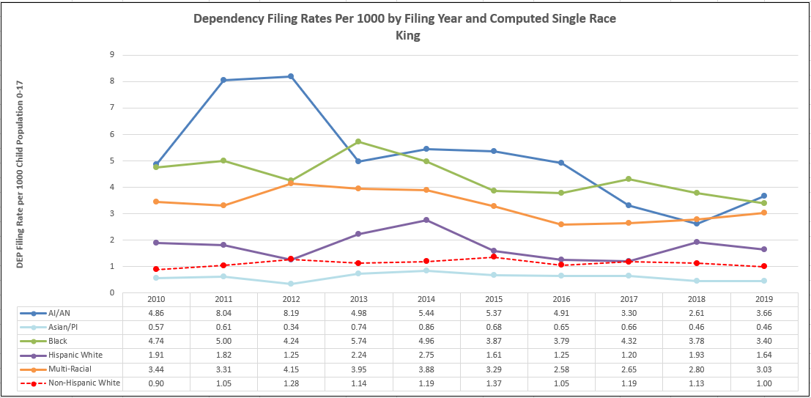

DEPENDENCY FILINGS VS DISMISSALS
Showing your court partners the filings and dismissals allows them to see trend for caseloads within the dependency court system.
Description Example: In 2017 and 2018, the number of dependency petitions filed exceeded the number of dismissals, suggesting a growing caseload within the dependency court system. However, there has been a notable shift in the subsequent years. Following a peak in 2019, with 4,876 dismissals, the number of dismissals has consistently exceeded the number of filings. For example, in 2022, a total of 2,589 dependency petitions were filed, whereas the number of dismissals reached 3,317.
Sources of Data: Fact Finding Excel, DPP Filings _OROD Month, Dismissal Cnts

FIGURE 8: DEPENDENCY FILINGS AND DISMISSALS, 2017-2022

Another way to show dependency filings with the filing rates and dismissal counts with a comparison to the child population for your county is through the Filing Count Rates.
Sources of Data: Fact Finding Excel, Filling Count Rate sheet

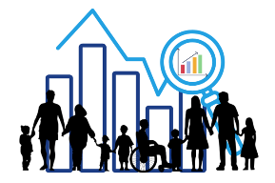
TIMELINESS MEASURES
Review dependency timeliness indicator data for the current quarter and compare to the prior quarter and year. Help your court partners understand what the data is telling them for each timeliness measure.
Examples of what you can share with your court partners about the data;
- How is your county preforming? Do you notice changes as compared to the past quarter/year?
- What measure(s) is your county preforming well in?
- What measure(s) might require your attention and or the attention of your cross-system teams?
- What are possible reasons for what you observe? What more do you need to know to understand the data story?
- How does your county compare to the state and comparable counties in your region and state?
- Is your county meeting your benchmarks set by your dependency court partner workgroups?

Fact Finding
Sources of Data: Fact Finding Excel: Fact Finding: filter for A, B, D Compliant, Non-Compliant, Non-Compliant -Due, No Fact-Finding Codes to get the correct compliance %.

Summary Outcome Measures Dashboard - select on the dash the counties, state, FJCIP etc. that you want to compare in your graph. Summary Outcomes Graph sheet -will be able to copy and paste or snip the graphs created for you.

You can use graphs, similar to those displayed here, to visualize your data and make comparisons with all FJCIP courts and other counties in the state. These visuals provide a clear way for your court partners to assess how your performance aligns with trends across the state.

OBJECTIVE 1: Fact-Finding within 75 Days

First Dependency Review
Sources of Data: Review Hearing Excel, First Review Hearing sheet; filter for A, B, D
Compliant, Non-Compliant, Non-Compliant Due, No RH Codes

OBJECTIVE 2: Review Hearings Every Six Months

Permanency Planning Hearings
Sources of Data: Perm Planning Excel Perm Planning 12mnth; filter for A, B, E
Compliant, Non-Compliant., Non-Compliant -Due, No Perm Plan Code

OBJECTIVE 3: Permanency Planning Hearing within 12 Months

Termination Petitions within 15 months
Sources of Data: TPR Adoptions Excel, TPR Pet 15mnth; filter for A, B, F, G
Compliant, Compliant Good Cause Found, Non-compliant by 15 months, Non-Compliant -due, no term pet codes

OBJECTIVE 5: Termination of Parental Rights Petition filed Within 15 Months of Out-of-Home Care

Permanency Outcomes
Sources of Data: Perm Outcomes Exit from care sheet and Median months to outcome sheets

OBJECTIVE 4: Permanency Achieved Before 15 Months Out-of-Home Care

PERMANENCY OUTCOMES, MEASURED BY EXITS
Within the dependency court system, there are multiple avenues for children to exit the system such as adoption, legal guardianship, and reunification with parents. You can talk about the exits by type (Table 9) as well as by race and ethnicity (Figure 9).
Description Example: In 2022, a total of 3,158 exits from out-of-home care were recorded. Among these exits, 55% involved reunification with parents, 26% were through adoption, and 7% were achieved through legal guardianships (Table 9).
Sources of Data: Perm Outcomes Excel, Exits from care sheet
*be sure to select year you want to review in row 7 Episode Exit year

TABLE 9: STATEWIDE EXITS BY TYPE, 2022
 | N | %
Reunification | 1,722 | 55%
Adoptions | 809 | 26%
Emancipation | 184 | 6%
Guardianship | 232 | 7%
Data extracted: 2/6/2023
Description Example: In 2022, the highest proportion of cases statewide that resulted in reunification was observed among Hispanic/Latino children, as shown in Figure 9. Specifically, 63% of cases involving Hispanic/Latino children ended with successful reunification. In comparison, the proportions of reunification for Black, American Indian/Alaska Native (AI/AN), and White children were 51%, 56%, and 58% respectively (see Dashboard, Permanency outcome here).

FIGURE 9: 2022 REUNIFICATION PROPORTIONS, BY RACE AND ETHNICITY

Data extracted: 2/6/2023

Courts and their partners may be interested in understanding how children leave the system. Here's an example of how you can simplify the information in the iDTR for sharing. You can show percentages of children exiting care by race and ethnicity across various exit types.
Sources of Data: Perm Outcomes Excel Exits by Race and Ethnicity

Exits from care in 2020, based on racial breakdown, are as follows:

PERCENTAGES | AI/AN | Asian/PI | Black | White | Hispanic | Multi-AI/AN | Multi-Black | Multi-Other
Adoption | 4 | 4 | 23 | 35 | 9 | 6 | 13 | 6
Aged Out | 2 | 4 | 27 | 21 | 20 | 11 | 13 | 4
Guardianship | 6 | 24 | 15 | 18 | 6 | 12 | 9 | 9
Reunification | 3 | 5 | 18 | 35 | 15 | 7 | 16 | 1

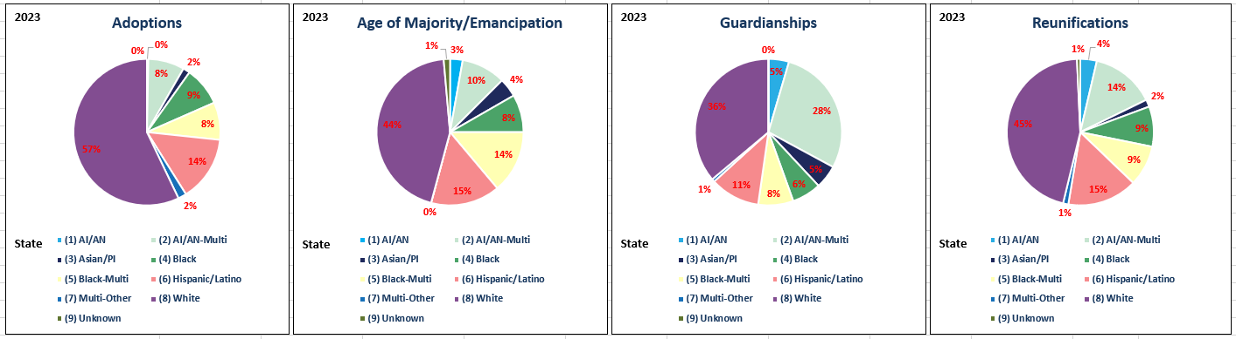

Description Example: The majority of adoptions involved white children, with 57%. Hispanic children accounted for 14% of these adoptions, while Black children comprised 9%, and multi-racial children/other made up another 2%. (see Dashboard, Permanency outcome here).

The Dash also has additional resources race/ethnicity data. DependencyDashboard | Tableau Public
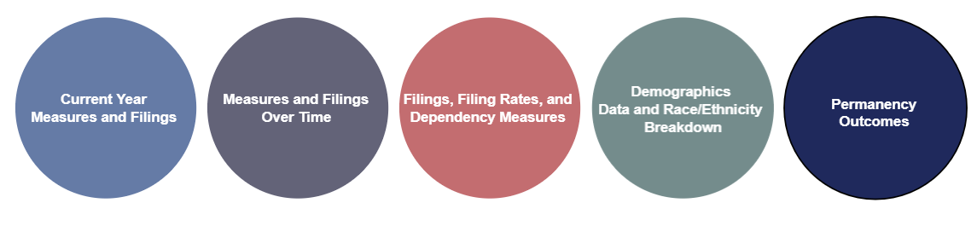
This tool will allow you to use filters by outcome types, by race/ethnicity for your county, other counties, as well as the state.
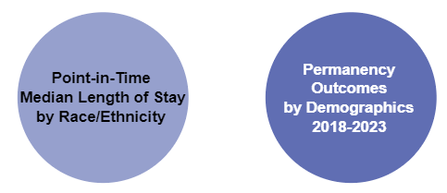

Adoptions
You can use graphs, similar to those displayed here, to visualize your adoptions data and make comparisons with all FJCIP courts and other counties in the state.
Sources of Data: TPR Adoption Excel Adoption 6mnth sheet; filter for A, B Median Adoption 6months sheet

OBJECTIVE 6: Adoption Completed Within Six Months of Termination Order

Re-Dependency

You can provide data on the percentage of DEP filings involving a child with a prior case that was later dismissed. This information can be valuable for your local team when working with these families, highlighting potential gaps in services or support from previous cases.
Sources of Data: ReDepepdency Excel Workbook, Prior Dependency Case, Time to Prior Months; filter by Prior DEP Dismissal Reason -unselect Order of Dependency -Not Established, Prior DEP County Same -unselect No.
Example Description: Between 2019 and 2022, there was a slight increase in the percentage of petitions with prior dependency from 10% in 2019 to 11.7% in 2022.

While the increase isn't substantial, it's important for us to keep an eye on this trend and monitor it closely.

DEPENDENCY SYSTEM PROJECTS AND GOALS

In this section review your dependency projects and progress towards your goals:

- Share your innovations: Highlight any innovative approaches or strategies your team has implemented in the realm of dependency. Explain who is supporting this work and how it contributes to your overall goals.

- Measurable outcomes: Provide data, if available, on measurable outcomes related to your dependency projects. This could include statistics on improvements, successes, or any positive changes resulting from your initiatives.

- Address challenges and solutions: Acknowledge any challenges your team has encountered during implementation of these projects. Alongside these challenges, offer possible solutions or strategies you're exploring to overcome them.

- Workgroup updates: Share updates on any workgroups that are focused on dependency. Mention upcoming meetings, training opportunities, and ways for team members to get involved.

- Visual elements: Consider incorporating photos into your report. They can add a personal touch and help illustrate the work being done, especially for team members who may not be in the courthouse regularly.

By covering these points, you can provide a comprehensive overview of your dependency projects and engage your team in discussions about progress, challenges, and opportunities for improvement.

