**Trauma Workers**

**Self-Assessment for Self-Care**

**By**

**Kathleen Regan Figley, MS, DMin**

**Charles R. Figley, PhD**

**Tulane University Traumatology Institute**

Foreword

The first version of this handbook as written for first responders and others who worked professionally with the traumatized. My last book, *First Do No Self Harm*, was written by and for physicians. Nurses and physicians often do not follow their own advice regarding self-care. Thus, ***Trauma Workers Self-Assessment for Self-Care*** helps those who help the traumatized. We think this includes you who sometimes forget about your own self-care attending to the traumatized, be they strangers or friends and family.

We hope that you take your own mental health into consideration and read and use this handbook. Use it to build your resilience to secondary stress by learning about your own weaknesses and particular vulnerabilities. Then developing a self-care plan, not unlike an exercise plan and a diet.

As they say when an airline prepares passengers for the trip they instruct us to first put the mask on ourselves before assisting others. This handbook and focusing on self-care, represents the mask that needs to be secured before for fore helping others. We must be fit and focused to help the traumatized. We hope you will continue to benefit from this resource and take better care of yourself as you work with the traumatized, than we did at your age.

|  |  |
| --- | --- |
| **Table of Contents** | |
| **Chapter 1: Introduction** | |  |
| Owner’s Manual | | |
| Resilience to Secondary Trauma | | |
| Timeline Activity – Part 1 | | |
| Timeline Activity – Part 2 | | |
| **Chapter 2:** **Assessments: Personal** | |
| Measuring Life Stress | |
| How Vulnerable Are You to Stress? | |
| Ego Resiliency Scale | |
| Building Personal Resilience | |
| Healthy Coping Strategies | |
| Checking Your Basic Needs | |
| Satisfaction with Life Scale | |
| **Chapter 3: Assessments: Professional** | |
| Professional Quality of Life (Satisfaction, Fatigue, Burnout) | |
| Checking Basic Needs at Work | |
| Early Warning Signs | |
| General Self-Care | |
| Body Scan Activity | |
| Compassion Stress Management Techniques | |
| **Chapter 4: Toward a Resilient Person** | |
| Caregiver Reactions to Stress | |
| Impact on Professional Functioning | |
| Healthy Coping Strategies | |
| **Chapter 5: Self-Care Planning Tool** | |
| Step 1. Self-Assessment | |
| Part A: Personal Reflections – Current Level of Self-Care | |
| Part B: Life Stress, Resilience and Coping | |
|  | |
| Step 2 Setting Your SMART Goals  **(S**pecific – **M**easurable – **A**ttainable – **R**ealistic – **T**ime-Based) | |
| Part A **Life Stress, Resilience, and Coping** | |
| Part B [start here] | |
| Part C | |

**Chapter 1: Introduction**

This chapter has you focus on your past to help plan for the future. The first section is the Timeline Activity. This helps you identify your major life activities so far in your life. The next activity is determining how many life change stressors forced you to cope.

**Timeline Activity**

Purpose: Identify stress and coping patterns

Instructions:

Mark vertical line at times in life when challenged: up for joyous or celebratory, down for stressful or traumatic

Mark level of intensity by length of line

Note coping strategies – both healthy and non-healthy

Example:

|  |
| --- |
| birth |

|  |
| --- |
| now |

|  |
| --- |
| Age 5 -Little sister born |

|  |
| --- |
| Age 17 – High School Graduation |

|  |
| --- |
| Age 22 – Married |

|  |
| --- |
| Age 10 – Parents divorced |

|  |
| --- |
| Age 11 – Best friend moved away |

|  |
| --- |
| Age 32 – Divorced |

Age 40 – Serious accident with injuries

Coping Strategies:

Age 5 – family celebrated with big party, had a lot of fun, parents got drunk

Age 10 – talked to grandparents almost every day

Age 11 – cried by self, did not talk to anyone about it

Age 17 – went drinking with friends after the graduation ceremony

Age 22 – small wedding, parents not invited, just a few friends

Age 32 – went to marriage counseling, then went to counseling alone until more than six months after the divorce, started drinking every day

Age 40 – started drinking heavily to avoid thinking about the people who were hurt

Use the next page to draw your Timeline and note your coping patterns. **Timeline Activity: Part 1**

Highest level of joy

or celebration

|  |  |  |
| --- | --- | --- |
| 10 |  |  |
| 9 |  |  |
| 8 |  |  |
| 7 |  |  |
| 6 |  |  |
| 5 |  |  |
| 4 |  |  |
| 3 |  |  |
| 2 |  |  |
| 1 |  |  |
| Birth |  | now |
| 1 |  |  |
| 2 |  |  |
| 3 |  |  |
| 4 |  |  |
| 5 |  |  |
| 6 |  |  |
| 7 |  |  |
| 8 |  |  |
| 9 |  |  |
| 10 |  |  |

Highest level

of stress or trauma

Coping Strategies:

(continue on back of page if necessary)**Timeline Activity: Part 2**

Identify Buddy ___________________________

Write Name Here ___________________________

* Discuss with your buddy the outcome of your timeline process. (5 minutes each)

Focus: What were the factors that contributed to bouncing back from stressful or traumatic events?

* Group Discussion:

What are the factors as a group that mark resiliency?

**Chapter 2:** **Assessments: Personal**

**This chapter guide you through completing some information tests that will inform your developing your self-care plan.**

**Measuring Life Stress3**

**Instructions**: Circle the number of any event which has occurred in your life **over the past 12 months**. Add up the numbers for your total score.

|  |  |  |  |
| --- | --- | --- | --- |
| **Event** | **Scale of**  **Impact** | **Event** | **Scale of**  **Impact** |
| Death of spouse | 100 | Son or daughter leaving home | 29 |
| Divorce | 73 | Change in responsibility at work | 29 |
| Marital separation | 65 | Outstanding personal achievement | 28 |
| Jail term | 63 | Spouse begins/stops work | 26 |
| Death of close family member | 63 | Begin or end school | 26 |
| Personal injury or illness | 53 | Change in living conditions | 25 |
| Marriage | 50 | Revision of personal habits | 24 |
| Fired at work | 47 | Trouble with boss | 23 |
| Marital reconciliation | 45 | Change in work hours or conditions | 20 |
| Retirement | 45 | Change in residence | 20 |
| Change in health of family member | 44 | Change in schools | 20 |
| Pregnancy | 39 | Change in recreation | 19 |
| Sex difficulties | 39 | Change in church activity | 19 |
| Gain of new family member | 39 | Change in social activity | 18 |
| Business readjustment | 39 | Small mortgage or loan | 17 |
| Change in financial state | 38 | Change in sleep habits | 16 |
| Death of a close friend | 37 | Change in number of family get-togethers | 15 |
| Change to a different line of work | 36 | Change in eating habits | 15 |
| Change in number of arguments with spouse | 35 | Vacation | 13 |
| High mortgage | 31 | Christmas | 12 |
| Foreclosure of mortgage or loan | 31 | Minor violations of the law | 11 |
| Trouble with in-laws | 29 | **TOTAL SCORE** |  |

3 **The Social Readjustment Rating Scale** was designed to reflect the cumulative stress to which an individual has been exposed over a period of time (Holmes & Holmes, 1970; Holmes and Rahe, 1967, Rahe and Arthur, 1978). “Life change units” are used to measure life stress in the areas noted above.

**Interpretation:**

Score 150-199: If your current level of stress continues and/or you do not adopt effective stress management strategies, you have a 37% chance of a minor illness in the next two years.

Score 200-299: If your stress level continues and you do nothing to change your adaptive strategies, you have a 51% chance of developing a major illness in the next two years.

Score over 300: You have a 79% chance of a major health breakdown in the next two years. It is recommended that you begin adding effective coping strategies to your life style.

**Note:**

Major life stressors may impact decision making. When an individual is in danger of suffering the ill effects of life crises, it is best to limit as much as possible any additional disruption. As an example, if someone recently lost a loved one or lost a job, it may be best to wait until some time has passed before making a major decision like looking for another job or moving to another town.

**Questions to Consider:**

Does your score seem to accurately reflect the level of stress in your life as you see it? Why or why not?

What does your perception of life events have to do with the effects of stress on you?

Does your current level of self-care enhance your stress resiliency or leave you vulnerable?

**How Vulnerable Are You To Stress?4**

In modern society, most of us can't avoid stress. But we can learn to behave in ways that lessen its effects. Researchers have identified a number of factors that affect one's vulnerability to stress - among them are eating and sleeping habits, caffeine and alcohol intake, and how we express our emotions. The following questionnaire is designed to help you discover your vulnerability quotient and to pinpoint trouble spots. Rate each item from 1 (always) to 5 (never), according to how much of the time the statement is true of you. Be sure to mark each item, even if it does not apply to you - for example, if you don't smoke, circle 1 next to item six.

|  |  |  |  |  |  |
| --- | --- | --- | --- | --- | --- |
|  | Always |  | Sometimes |  | Never |
| 1. I eat at least one hot, balanced meal a day. | 1 | 2 | 3 | 4 | 5 |
| 2. I get 7-8 hours of sleep at least four nights a week. | 1 | 2 | 3 | 4 | 5 |
| 3. I give and receive affection regularly. | 1 | 2 | 3 | 4 | 5 |
| 4. I have at least one relative within 50 miles, on whom I can rely. | 1 | 2 | 3 | 4 | 5 |
| 5. I exercise to the point of perspiration at least twice a week. | 1 | 2 | 3 | 4 | 5 |
| 6. I limit myself to less than half a pack of cigarettes a day. | 1 | 2 | 3 | 4 | 5 |
| 7. I take fewer than five alcohol drinks a week. | 1 | 2 | 3 | 4 | 5 |
| 8. I am the appropriate weight for my height. | 1 | 2 | 3 | 4 | 5 |
| 9. I have an income adequate to meet basic expenses. | 1 | 2 | 3 | 4 | 5 |
| 10. I get strength from my religious beliefs. | 1 | 2 | 3 | 4 | 5 |
| 11. I regularly attend club or social activities. | 1 | 2 | 3 | 4 | 5 |
| 12. I have a network of friends and acquaintances. | 1 | 2 | 3 | 4 | 5 |
| 13. I have one or more friends to confide in about personal matters. | 1 | 2 | 3 | 4 | 5 |
| 14. I am in good health (including eye-sight, hearing, and teeth). | 1 | 2 | 3 | 4 | 5 |
| 15. I am able to speak openly about my feelings when angry or worried. | 1 | 2 | 3 | 4 | 5 |
| 16. I have regular conversations with the people I live with about domestic problems - for example, chores and money. | 1 | 2 | 3 | 4 | 5 |
| 17. I do something for fun at least once a week. | 1 | 2 | 3 | 4 | 5 |
| 18. I am able to organize my time effectively. | 1 | 2 | 3 | 4 | 5 |
| 19. I drink fewer than three cups of coffee (or other caffeine-rich drinks) a day. | 1 | 2 | 3 | 4 | 5 |
| 20. I take some quiet time for myself during the day. | 1 | 2 | 3 | 4 | 5 |

4University of California, Berkeley Wellness Letter, August 1985. Scale Developers: Lyle Miller and Alma Dell Smith of Boston University Medical Center.

|  |  |
| --- | --- |
| **Scoring Instructions**:  To calculate your score, add up the figures and subtract 20. | **Self-Care Plan**:   * Notice that nearly all the items describe situations and behaviors over which you have a great deal of control. * Review the items on which you scored three or higher.      * List those items in your self-care plan. * Concentrate first on those that are easiest to change - for example, eating a hot, balanced meal daily and having fun at least once a week - before tackling those that seem difficult. |
| **Score Interpretation**:  **Below 10** indicates **excellent resistance** to stress.    **Over 30** indicates **some vulnerability** to stress;  **Over 50** indicates **serious vulnerability** to stress.  **Over 75 indicates extreme vulnerability to stress.** |

This space may be used for notes and/or reflections:

|  |  |  |  |  |  |  |
| --- | --- | --- | --- | --- | --- | --- |
| **Ego Resiliency Scale (J. Block & Kremen, 1996)** | | | | | | |
| This scale consists of 14 items, each responded to on a 4-point Likert scale, ranging from 1 (*does not apply at all*) to 4 (*applies very strongly*). Answer **how true the following characteristics are as they apply to you generally**: | | | | | | |
| 1. I am generous with my friends. | | 1  Does not apply at all | 2  Applies  slightly | | 3  Applies somewhat | 4  Applies very strongly |
| 1. I quickly get over and recover from being startled. | | 1  Does not apply at all | 2  Applies  slightly | | 3  Applies somewhat | 4  Applies very strongly |
| 1. I enjoy dealing with new and unusual situations. | | 1  Does not apply at all | 2  Applies  slightly | | 3  Applies somewhat | 4  Applies very strongly |
| 1. I usually succeed in making a favorable impression on people. | | 1  Does not apply at all | 2  Applies  slightly | | 3  Applies somewhat | 4  Applies very strongly |
| 1. I enjoy trying new foods I have never tasted before. | | 1  Does not apply at all | 2  Applies  slightly | | 3  Applies somewhat | 4  Applies very strongly |
| 1. I am regarded as a very energetic person. | | 1  Does not apply at all | 2  Applies  slightly | | 3  Applies somewhat | 4  Applies very strongly |
| 1. I like to take different paths to familiar places. | | 1  Does not apply at all | 2  Applies  slightly | | 3  Applies somewhat | 4  Applies very strongly |
| 1. I am more curious than most people. | | 1  Does not apply at all | 2  Applies  slightly | | 3  Applies somewhat | 4  Applies very strongly |
| 1. Most of the people I meet are likable. | | 1  Does not apply at all | 2  Applies  slightly | | 3  Applies somewhat | 4  Applies very strongly |
| 1. I usually think carefully about something before acting. | | 1  Does not apply at all | 2  Applies  slightly | | 3  Applies somewhat | 4  Applies very strongly |
| 1. I like to do new and different things. | | 1  Does not apply at all | 2  Applies  slightly | | 3  Applies somewhat | 4  Applies very strongly |
| 1. My daily life is full of things that keep me interested. | | 1  Does not apply at all | | 2  Applies  slightly | 3  Applies somewhat | 4  Applies very strongly |
| 1. I would be willing to describe myself as a pretty “strong” personality. | | 1  Does not apply at all | | 2  Applies  slightly | 3  Applies somewhat | 4  Applies very strongly |
| 1. I get over my anger at someone reasonably quickly. | | 1  Does not apply at all | | 2  Applies  slightly | 3  Applies somewhat | 4  Applies very strongly |
|  |  |  |  | |  |  |

**Scoring Interpretation**

|  |  |  |  |  |  |
| --- | --- | --- | --- | --- | --- |
| Score | 47-56 | 35-46 | 23-34 | 11-22 | 0-10 |
|  | **Very High Resiliency Trait** | **High Resiliency Trait** | **Undetermined Trait** | **Low Resiliency Trait** | **Very Low Resiliency Trait** |

**Building Personal Resilience5**

The following list contains numerous characteristics that combine to form resilience. Check off all items which now describe you.

|  |  |
| --- | --- |
|  | I have a good self-concept. |
|  | I have good self-esteem. |
|  | I am sensitive to the needs of others. |
|  | I am generally cooperative with others. |
|  | I am socially responsive. |
|  | I have a good sense of humor. |
|  | I am able to postpone getting my needs met (I can delay gratification). |
|  | I am generally flexible. |
|  | I can control my impulses when I need to do so. |
|  | I believe in the future and plan for it. |
|  | I have a good support system. |
|  | I recognize that I have many opportunities available to me. |
|  | I respect individual human beings. |
|  | I respect appropriate authority. |
|  | I am able to look for more than one solution to a problem. |
|  | I am able to plan ahead. |
|  | I have hobbies and interests beyond my traumas. |
|  | I have a positive view of life and see life’s joys (as well as its sorrows). |
|  | I can problem solve and have a strategy which I use. |
|  | I have a sense of spirituality. |
|  | I celebrate myself regularly. |
|  | I celebrate others regularly. |
|  | I believe that I have some level of control over myself and others. |
|  | I would rather take action than wait for something to happen to me. |
|  | I am able to find meaning even in bad things. |
|  | I am someone others like and love. |
|  | I am able to find someone to help me when I need it. |
|  | I can ask questions in a creative way. |
|  | I have a conscience that allows me to see my own goodness. |
|  | I have a “knowing” about things that happen to and around me. |
|  | I can disengage and separate from others if they are not good for me. |
|  | I can attach to others and connect. |

5 Williams and Poijula. (2002). The PTSD Workbook: Simple, Effective Techniques for Overcoming Traumatic Stress Symptoms.

|  |  |  |
| --- | --- | --- |
| **Healthy Coping Strategies**  Check off all strategies that you regularly employ. Write a total number for each category. | | |
| **Cognitive** | **Emotional** | **Behavioral** |
| 1. o Moderation* 2. o Write things down 3. o Make small, daily decisions 4. o See the decisions you are already making 5. o Giver yourself permission to ask for help 6. o Plan for the future 7. o Get the most information you can to help make decisions 8. o Anticipate needs 9. o Remember you have options 10. o Review previous successes 11. o Problem solve 12. o Have a Plan “B” 13. o Break large tasks into smaller ones | 1. o Moderation 2. o Allow yourself to experience what you feel 3. o Label what you are experiencing 4. o Give yourself permission to ask for help 5. o Be assertive when necessary 6. o Keep communication open with others 7. o Remember you have options 8. o Use your sense of humor 9. o Have a buddy with whom you can vent 10. o Use “positive” words and language | 1. o Moderation 2. o Spend time by yourself 3. o Spend time with others 4. o Limit demands on time and energy 5. o Help others with tasks 6. o Give yourself permission to ask for help 7. o Do activities that you previously enjoyed 8. o Take different routes to work or on trips 9. o Remember you have options 10. o Find new activities that are enjoyable and (mildly) challenging 11. o Set goals, have a plan 12. o Relax |
| **Spiritual** | **Interpersonal** | **Physical** |
| 1. o Moderation 2. o Discuss changed beliefs with spiritual leader 3. o Meditation 4. o Give yourself permission to ask for help 5. o Practice rituals of your faith/beliefs 6. o Spiritual retreats/workshops 7. o Prayer 8. o Remember you have options 9. o Mindfulness 10. o Find spiritual support 11. o Read Spiritual literature | 1. o Moderation 2. o Give yourself permission to ask for help 3. o Take time to enjoy time with trust friend/partner 4. o Hugs 5. o Healthy boundaries 6. o Remember to use “I’ statements 7. o Use humor to diffuse tense conversations 8. o Play together 9. o Talk with trusted partner/ friend 10. o Apologize when stress causes irritable behavior or outbursts 11. o State needs and wants as clearly as possible | 1. o Moderation 2. o Aerobic exercise 3. o See doctor and dentist 4. o Routine sleep patterns 5. o Minimize caffeine, alcohol, and sugar 6. o Give yourself permission to ask for help 7. o Eat well-balanced, regular meals 8. o Drink water 9. o Wear comfortable clothes 10. o Engage in physical luxuries: spa, massage, bath, exercise trainer 11. o Remember to breathe – deeply 12. o Take mini-breaks |

6 Adapted from The Woman’s Comfort Book (Louden, 1992)

|  |  |  |  |
| --- | --- | --- | --- |
| **Checking Your Basic Needs**6 | | | |
| Basic Self-Care Needs | Yes | No | Goal |
| Do I usually get enough sleep? |  |  |  |
| Do I usually eat something fresh and unprocessed every day? |  |  |  |
| Do I allow time in my week to touch nature, no matter how briefly? |  |  |  |
| Do I get enough sunlight, especially in wintertime? |  |  |  |
| Do I see my medical practitioner at least once a year? |  |  |  |
| Do I see a dentist every six months? |  |  |  |
| Do I get regular sexual thrills? |  |  |  |
| Do I get enough ***fun*** exercise? |  |  |  |
| Am I hugged and touched amply? |  |  |  |
| Do I make time for friendship?  Do I nurture my friendships? |  |  |  |
| Do I have friends I can call when I am down, friends who really listen? |  |  |  |
| Can I honestly ask for help when I need it? |  |  |  |
| Do I regularly release negative emotions in a healthy manner? |  |  |  |
| Do I forgive myself when I make a mistake? |  |  |  |
| Do I do things that give me a sense of fulfillment, joy and purpose? |  |  |  |
| Is there abundant beauty in my life? |  |  |  |
| Do I allow myself to see beauty and to bring beauty into home and office? |  |  |  |
| Do I make time for solitude? |  |  |  |
| Am I getting daily or weekly spiritual nourishment? |  |  |  |
| Can I remember the last time I laughed until I cried? |  |  |  |
| Do I accept myself for who I am? |  |  |  |

**Satisfaction with Life**

DIRECTIONS

* Below are five statements with which you may agree or disagree.
* Using the 1-7 scale below, indicate your agreement with each item by placing the appropriate number in the line preceding that item.
* Please be open and honest in your responding.

SCALE

|  |  |  |  |  |  |  |
| --- | --- | --- | --- | --- | --- | --- |
| 1 | 2 | 3 | 4 | 5 | 6 | 7 |
| Strongly Disagree | Disagree | Slightly Disagree | Neither Agree or Disagree | Slightly Agree | Agree | Strongly Agree |

______1. In most ways my life is close to my ideal.

______2. The conditions of my life are excellent.

______3. I am satisfied with life.

______4. So far I have gotten the important things I want in life.

______5. If I could live my life over, I would change almost nothing.

_______ TOTAL (add items 1 through 5)

INTERPRETATION

|  |  |  |  |  |  |  |
| --- | --- | --- | --- | --- | --- | --- |
| 35 – 32 | 26 – 31 | 21 – 25 | 20 | 15 – 19 | 10 – 14 | 5 - 9 |
| **Extremely satisfied** | **Satisfied** | Slightly satisfied | Neutral | Slightly dissatisfied | **Dissatisfied** | **Extremely dissatisfied** |

Diener, E., Emmons, R.A., Larson, R.J., & Griffin, S. (1985). The satisfaction with life scale. Journal of Personality Assessment, 49, 71-75.

**Chapter 3: Assessments: Professional**

**If you are a professional working with the traumatized, the results of these tests will help you develop an effective and adaptable self-care plan.**

|  |
| --- |
| **PROFESSIONAL QUALITY OF LIFE SCALE (ProQOL)**  *Compassion Satisfaction and Compassion Fatigue – Version 5 (2009)*  When you help people, you have direct contact with their lives. As you may have found, your compassion for those you help can affect you in both positive and negative ways. Below are some questions about your experiences, both positive and negative, as a helper. Consider each of the following questions about you and your current work situation. Select the number that honestly reflects how frequently you experienced these things in the last 30 days.  1=Never 2=Rarely 3=Sometimes 4=Often 5=Very Often  _______1. I am happy.  _______2. I am preoccupied with more than one person I help.  _______3. I get satisfaction from being able to help people.  _______4. I feel connected to others.  _______5. I jump or am startled by unexpected sounds.  _______6. I feel invigorated after working with those I help.  _______7. I find it difficult to separate my personal life from my life as a helper.  _______8. I am not as productive at work because I am losing sleep over traumatic experiences of a person I help.  _______9. I think that I might have been affected by the traumatic stress of those I help.  _______10. I feel trapped by my work as a helper.  _______11. Because of my helping, I have felt "on edge" about various things.  _______12. I like my work as a helper.  _______13. I feel depressed because of the traumatic experiences of the people I help.  _______14. I feel as though I am experiencing the trauma of someone I have helped.  _______15. I have beliefs that sustain me.  _______16. I am pleased with how I am able to keep up with helping techniques and protocols.  _______17. I am the person I always wanted to be.  _______18. My work makes me feel satisfied.  _______19. I feel worn out because of my work as a helper.  _______20. I have happy thoughts and feelings about those I help and how I could help them.  _______21. I feel overwhelmed because my case load seems endless.  _______22. I believe I can make a difference through my work.  _______23. I avoid certain activities or situations because they remind me of frightening experiences of the people I help.  _______24. I am proud of what I can do to help.  _______25. As a result of my helping, I have intrusive, frightening thoughts.  _______26. I feel "bogged down" by the system.  _______27. I have thoughts that I am a "success" as a helper.  _______28. I can’t recall important parts of my work with trauma victims.  _______29. I am a very caring person.  _______30. I am happy that I chose to do this work. |

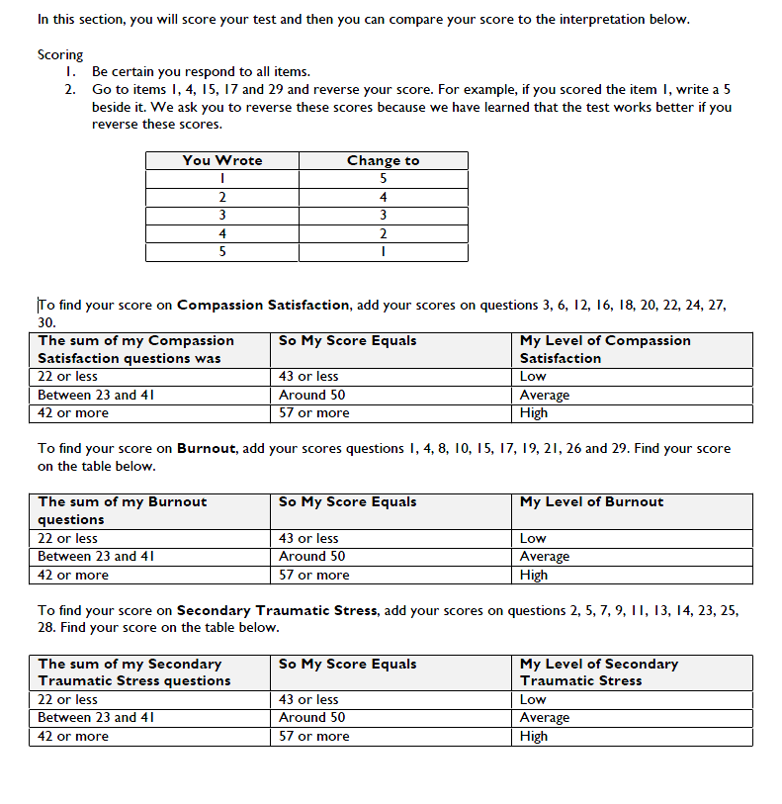

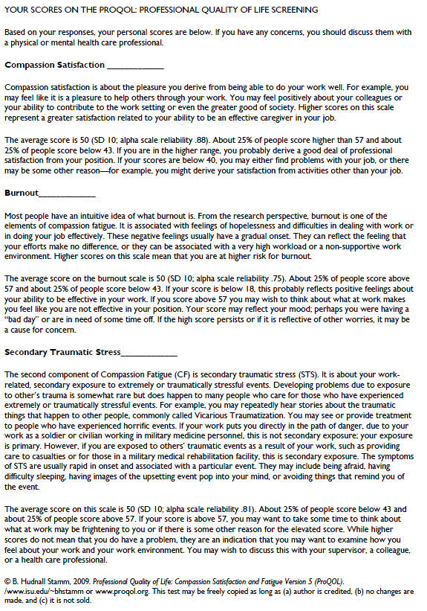

1. Look at the combination of scores and determine in which category your profile fits.
2. Refer back to for your Professional Assessment chart.

|  |  |  |  |
| --- | --- | --- | --- |
| 1. **ProQOL:** | **High** | **Average** | **Low** |
| Compassion Satisfaction | **57+** | 50 | **43-** |
| Burnout | **57+** | 50 | **43-** |
| Secondary Traumatic Stress | **57+** | 16-9 | **43-** |

* **Low** Secondary Traumatic Stress, **Low** Burnout, **High** Satisfaction: **Enjoy Your Job!**
* **High** Secondary Traumatic Stress, **High** Burnout, **Low** Satisfaction: **Change** Careers
* **Low** Secondary Traumatic Stress, **High** Burnout, **High** Satisfaction: **Change** Jobs
* **High** Secondary Traumatic Stress, **Low** Burnout, **High** Satisfaction: **Stay and Manage** Stress
* **Low** Secondary Traumatic Stress, **Low** Burnout, **Low** Satisfaction: **Change** Population Served

|  |  |  |  |
| --- | --- | --- | --- |
| **Checking Your Basic Needs @ Work**7 | | | |
| Self-Care @ Work | Yes | No | Comments/Reflections |
| Do I take a lunch break every day and do something unrelated to work? |  |  |  |
| Do I work reasonable hours? |  |  |  |
| Do I schedule “breathing room" every day so I can step back, and reevaluate my priorities? |  |  |  |
| Is my office free of clutter? |  |  |  |
| Do I have adequate lighting and clean air? |  |  |  |
| Do I delegate work to free my time and empower others? |  |  |  |
| Do my family/friends honor my work time? If no, have I asked them? |  |  |  |
| Do I have blocks of uninterrupted time without distractions and interruptions? |  |  |  |
| Do I have a DO NOT DISTURB sign? |  |  |  |
| Have I scheduled specific times for returning phone calls and checking e-mail? |  |  |  |
| Have I stopped taking on more than I can handle? |  |  |  |
| Do I drink enough water when I am at work? |  |  |  |
| Do I have comfortable shoes/slippers at my office? |  |  |  |
| Do I schedule time off from work (sick leave and/or vacation time) to take care of myself? |  |  |  |
| Do I have someone to talk with about my professional life? |  |  |  |
| Do I have creature comforts that make my office pleasant? (music and other sounds, aroma, artwork) |  |  |  |
| Do I say yes to commitments that I later regret? |  |  |  |

7 Adapted from Life Makeovers (2000) by Cheryl Richardson

8 Adapted from Life Makeovers (2000) by Cheryl Richardson.

|  |  |  |  |
| --- | --- | --- | --- |
| **Early Warning Signs8** | | | |
| Please be honest with yourself (no need to show anyone your answer) in answering the foIlowing question: know I’m headed for trouble when: | | | |
| 1. 1. | | | |
| 1. 2. | | | |
| 1. 3. | | | |
| 1. 4. | | | |
| 1. 5. | | | |
| **General Self-Care** | **Yes** | **No** | **Comments/Reflections** |
| I am willing to ask for help. |  |  |  |
| I know what to ask for. |  |  |  |
| I reevaluate my priorities. |  |  |  |
| I identify what is most important and deserving of my focus. |  |  |  |
| I let go of that which detracts from my ability to focus. |  |  |  |

**Body Scan Activity**

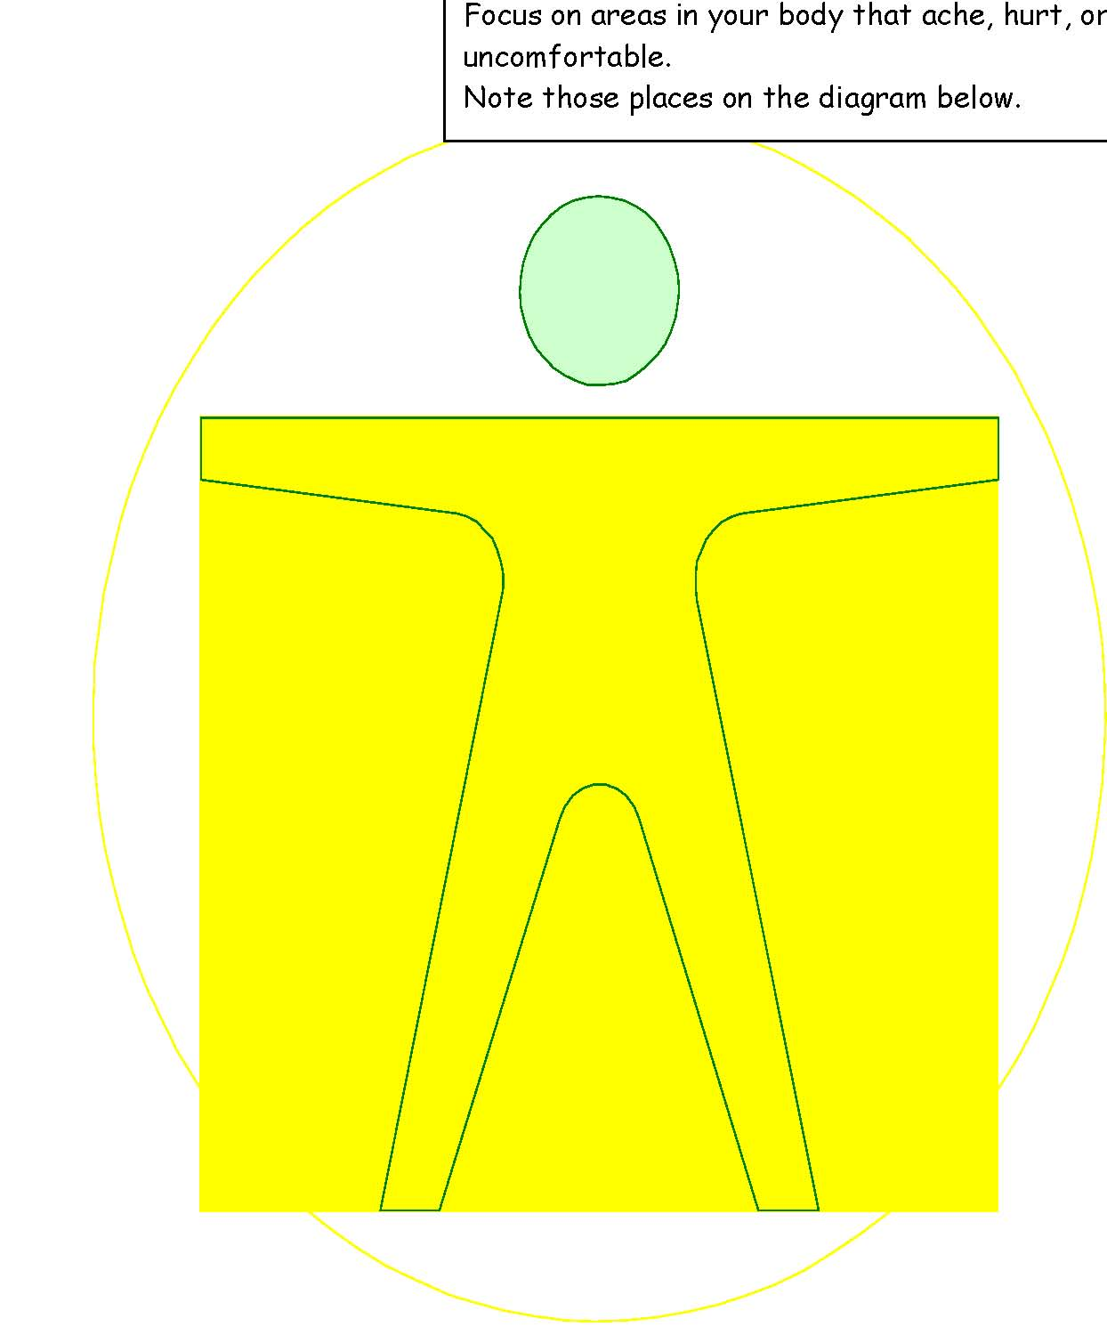

**Compassion Stress Management Techniques**

|  |  |  |
| --- | --- | --- |
| Technique | Currently Use | Will Add to Self-Care Plan |
| When Working with Clients |  |  |
|  |  |  |
| Breath-Work |  |  |
|  |  |  |
| Self-talk |  |  |
|  |  |  |
| Movement |  |  |
|  |  |  |
| Between Clients/After Work |  |  |
|  |  |  |
| Breathing Meditation |  |  |
|  |  |  |
| Prayer and Meditation |  |  |
|  |  |  |
| Visualization (e.g., safe place) |  |  |
|  |  |  |
| Emotional Freedom Technique (EFT) or Thought Field Therapy (TFT) |  |  |
|  |  |  |
| Journaling |  |  |
|  |  |  |
| Art Therapy |  |  |
|  |  |  |
| Music Therapy |  |  |
|  |  |  |
| Poetry Therapy |  |  |
|  |  |  |
| All hobbies and absorbing activities |  |  |
|  |  |  |
| Music and Other Creative Therapies |  |  |
|  |  |  |
| Dance and Other Kinesthetic Treatments |  |  |

**Chapter 4: Toward a Resilient Person**

This chapter helps you consider how resilient you are based on the above assessments and the ones contained here. The Caregiver Reactions in Table 1 provides a complete list of markers or symptoms you may have experienced that might be linked to past traumatic events. Your finding them in your own pattern of post-traumatic reactions will help guide your Self Care Plan (SCP). After you complete the measures in this chapter, answer the following question in your handbook: Do you find that you are mostly fine, most of the time? Do you find that you are mostly don’t really think about any bad memory?

And for those who said yes to the above, a follow-up question:

Do you find that in your life, there were just a few experiences that bothers you, but then the memory gradually evaporates?

|  |  |  |  |  |  |
| --- | --- | --- | --- | --- | --- |
| **Table 1: Caregiver Reactions to Stress** | | | | | |
| **Cognitive** | | **Emotional** | | **Behavioral** | |
| o Diminished concentration  o Confusion  o Spaciness  o Loss of meaning  o Decreased self-esteem  o Preoccupation with trauma  o Trauma imagery  o Apathy  o Rigidity  o Disorientation  o Whirling thoughts  o Thoughts of self-harm or harm toward others  o Self-doubt  o Perfectionism  o Minimization | | o Powerlessness  o Anxiety  o Guilt  o Anger/rage  o Survivor guilt  o Shutdown  o Numbness  o Fear  o Helplessness  o Sadness  o Depression  o Hypersensitivity  o Emotional roller coaster  o Overwhelmed  o Depleted | | 1. o Clingy 2. o Impatient 3. o Irritable 4. o Withdrawn 5. o Moody 6. o Regression 7. o Sleep disturbances 8. o Appetite changes 9. o Nightmares 10. o Hyper vigilance 11. o Elevated startle response 12. o Use of negative coping (smoking, alcohol or other substance abuse) 13. o Accident proneness 14. o Losing things 15. o Self harm behaviors | |
| **Spiritual** | | **Interpersonal** | | **Physical** | |
| o Questioning the meaning of life  o Loss of purpose  o Lack of self-satisfaction  o Pervasive hopelessness  o Ennui  o Anger at God  o Questioning of prior religious beliefs | | o Withdrawn  o Decreased interest in intimacy or sex  o Mistrust  o Isolation from friends  o Impact on parenting (protectiveness, concern about aggression)  o Projection of anger or blame  o Intolerance  o Loneliness | | 1. o Shock 2. o Sweating 3. o Rapid heartbeat 4. o Breathing difficulties 5. o Aches and pains 6. o Dizziness 7. o Impaired immune system | |
| **Table 2: Impact on Professional Functioning** | | | | | |
| **Performance of**  **Job Tasks** | **Morale** | | **Interpersonal** | | **Behavioral** |
| o Decrease in quality  o Decrease in quantity  o Low motivation  o Avoidance of job tasks  o Increase in mistakes  o Setting perfectionist standards  o Obsession about details | o Decrease in confidence  o Loss of interest  o Dissatisfaction  o Negative attitude  o Apathy  o Demoralization  o Lack of appreciation  o Detachment  o Feelings of incompleteness | | o Withdrawal from colleagues  o Impatience  o Decrease in quality of relationship  o Poor communication  o Subsume own needs  o Staff conflicts | | 1. o Absenteeism 2. o Exhaustion 3. o Faulty judgment 4. o Irritability 5. o Tardiness 6. o Irresponsibility 7. o Overwork 8. o Frequent job changes |

Impact on Professional Functioning

Table 2 lists the markers for measuring the impact of stress on professional functioning and its concomitant impact on the quality of the services and how many traumatized people may get on with their life following these vital services. Trauma work requires extraordinary commitment with compensation that does not represent how important is the work. Trauma work is hard and those professionals and volunteers who dedicate their life and career to attending to the traumatized. Salaries are insufficient, as are the adulation for their contributions to a more civil and compassionate society.

Alternatively, Table 3 discusses coping strategies that are healthy and lead to resilience to many psychological dysfunctions such as compassion fatigue, burnout, and vicarious trauma.

|  |  |  |
| --- | --- | --- |
| **Table 3: Healthy Coping Strategies** | | |
| **Cognitive** | **Emotional** | **Behavioral** |
| 1. o Moderation 2. o Write things down 3. o Make small, daily decisions 4. o See the decisions you are already making 5. o Giver yourself permission to ask for help 6. o Plan for the future 7. o Get the most information you can to help make decisions 8. o Anticipate needs 9. o Remember you have options 10. o Review previous successes 11. o Problem solve 12. o Have a Plan “B” 13. o Break large tasks into smaller ones | 1. o Moderation 2. o Allow yourself to experience what you feel 3. o Label what you are experiencing 4. o Give yourself permission to ask for help 5. o Be assertive when necessary 6. o Keep communication open with others 7. o Remember you have options 8. o Use your sense of humor 9. o Have a buddy with whom you can vent 10. o Use “positive” words and language | 1. o Moderation 2. o Spend time by yourself 3. o Spend time with others 4. o Limit demands on time and energy 5. o Help others with tasks 6. o Give yourself permission to ask for help 7. o Do activities that you previously enjoyed 8. o Take different routes to work or on trips 9. o Remember you have options 10. o Find new activities that are enjoyable and (mildly) challenging 11. o Set goals, have a plan 12. o Relax |
| **Spiritual** | **Interpersonal** | **Physical** |
| 1. o Moderation 2. o Discuss changed beliefs with spiritual leader 3. o Meditation 4. o Give yourself permission to ask for help 5. o Practice rituals of your faith/beliefs 6. o Spiritual retreats/workshops 7. o Prayer 8. o Remember you have options 9. o Mindfulness 10. o Find spiritual support 11. o Read Spiritual literature | 1. o Moderation 2. o Give yourself permission to ask for help 3. o Take time to enjoy time with trust friend/partner 4. o Hugs 5. o Healthy boundaries 6. o Remember to use “I’ statements 7. o Use humor to diffuse tense conversations 8. o Play together 9. o Talk with trusted partner/ friend 10. o Apologize when stress causes irritable behavior or outbursts 11. o State needs and wants as clearly as possible | 1. o Moderation 2. o Aerobic exercise 3. o See doctor and dentist 4. o Routine sleep patterns 5. o Minimize caffeine, alcohol, and sugar 6. o Give yourself permission to ask for help 7. o Eat well-balanced, regular meals 8. o Drink water 9. o Wear comfortable clothes 10. o Engage in physical luxuries: spa, massage, bath, exercise trainer 11. o Remember to breathe – deeply 12. o Take mini-breaks |

**Self-Care Planning Tool**

**Step 1. Self-Assessments:** Discuss your personal reflections with your Buddy with an emphasis on coping strategies and social support.

|  |  |
| --- | --- |
| Part A. Personal Reflections – Your Current Level of Self-Care | |
| List three work related stressors | 1.  2.  3. |
| List three personal stressors | 1.  2.  3. |
| List three ways you know you are stressed **(Early Warning Signs)8** | 1.  2.  3. |
| List three ways that your co-workers know you are stressed (signs and symptoms)1 | 1.  2.  3. |
| List three ways that your loved ones/friends know you are stressed(signs and symptoms) | 1.  2.  3. |
| List three methods at work by which you manage your stress3 | 1.  2.  3. |
| List three methods during non-work hours by which you manage your stress | 1.  2.  3. |
| List the first name of co-workers who are part of your work related support system | Co-Worker Name:  Co-Worker Name: |
| List the first name of loved ones/friends who are part of your support system | Loved One/Friend Name:  Loved One/Friend Name: |

|  |  |  |  |  |
| --- | --- | --- | --- | --- |
| Part B. Life Stress, Resilience and Coping | | | | |
| Instructions: Record your score/number of responses for each assessment in the section below, and circle the rating into which your score falls. | | | | |
| Measuring Life Stress | Score: ____ | **37% chance** | 51% chance | **79% chance** |
| Stress Vulnerability | Score: ____ | **Excellent resistance** | Some Vulnerability | **Serious Vulnerability** |
| Ego Resiliency Scale | Score: ____ | **High-Very High Resiliency Trait** | Undetermined Trait | **Low-Very Low Resiliency Trait** |
| Personal Resilience | # Items___ | **Many** | Some | **Few** |
| Healthy Coping | # Cognitive ____ | **Many** | Some | **Few** |
| # Emotional ____ | **Many** | Some | **Few** |
| # Behavioral ____ | **Many** | Some | **Few** |
| # Spiritual ____ | **Many** | Some | **Few** |
| # Physical ____ | **Many** | Some | **Few** |
| # Interpers. ____ | **Many** | Some | **Few** |
| Basic Needs | # Items _____ | **Many** | Some | **Few** |
| Satisfaction with Life | Score: _____ | **Satisfied** | Neutral | **Dissatisfied** |

Look at your timeline activity and your score pattern.

* If your scores fall mostly in the **green** column, you likely manage stressors well. High levels of life stress may be offset by healthy coping, high resilience, strong personal self-care practices, and overall satisfaction with one’s life.
* If your scores fall mostly in the **red** column, stressors may be taking their toll. High level stress which is not offset by resilience and coping indicate potential risk for health problems and negative impact on professional functioning. Under these circumstances, it is **critical** that the professional/paraprofessional increase coping strategies and/or seek help from a professional to offset the negative impact.
* If your scores fall in the middle category (**neutral**) you may be a bit more challenged in determining your score pattern. My recommendation is that you revise your score pattern by looking at the rating to which your score is closer. For the purposes of self-care planning, use the revised score pattern.

|  |  |  |  |  |
| --- | --- | --- | --- | --- |
| Part C. Practitioner Stress | | | | |
| Instructions: Record your score/number of responses for each assessment in the section below, and circle the rating into which your score falls. | | | | |
| Compassion Satisfaction  (as measured by ProQOL) | Score: ____ | **High** | Moderate | **Low** |
| Burnout  (as measured by ProQOL) | Score: ____ | **Low** | Moderate | **High** |
| Secondary Traumatic Stress  (as measured by ProQOL) | Score: ____ | **Low** | Moderate | **High** |
| Basic Needs at Work | # Items _____ | **Many** | Some | **Few** |

Look at your score pattern and determine into which category your profile fits. Remember these

are guidelines! You must analyze the data and compare that with your self-perceptions, and the

perceptions of your family, friends, and colleagues.

**Low Secondary Traumatic Stress, Low Burnout, High Compassion Satisfaction:**

**Enjoy Your Job!** Everything is working well. There’s a good fit with population served, work environment, and capacity to manage the emotional toll of the work.

**High Secondary Traumatic Stress, High Burnout, Low Compassion Satisfaction:**

**Change** Careers. Nothing is working well. The work environment is toxic, there’s an emotional toll resulting from hearing traumatic material, and there is an absence of joy in serving the client population.

**Low Secondary Traumatic Stress, High Burnout, High Compassion Satisfaction:**

**Change** Jobs. The work environment most likely is toxic. If at all possible, seek employment elsewhere. If options. If options are not available, consider ways in which toxicity can be neutralized via changes in own behavior (i.e., empathic discernment).

**High Secondary Traumatic Stress, Low Burnout, High Compassion Satisfaction:**

**Stay and Manage** the Emotional Toll of the Work. The work environment and population served are working well, but there’s an emotional toll resulting from hearing traumatic material. Your self-care plan is vital to sustain you and your ethical practice.

**Low Secondary Traumatic Stress, Low Burnout, Low Compassion Satisfaction:**

**Change** Population Served. The work environment is satisfactory and there is no emotional toll; there is no joy in working with the population being served.

**Step 2. Setting Goals:**

|  |  |
| --- | --- |
| Part A. Review Your Self-Assessment Results | |
| 1. Review the Self-Assessments as indicated in the sections below.  2. Identify the areas for which you are at risk.  3. **Below list ALL areas in which you want to make changes.**  4. After you have generated your list, rank the items, with 1 being the highest priority.  5. Discuss your lists with your Buddy. | |
| **Life Stress, Resilience and Coping**  (Timeline and Self-Assessment -  Step 1, Parts A & B) |  |
| **Practitioner Stress**  (Self-Assessment -  Step 1, Part C) |  |

|  |  |
| --- | --- |
| Part B. Setting Your SMART Goals  **S**pecific – **M**easurable – **A**ttainable – **R**ealistic – **T**ime-Based | |
| Example of a SMART Goal: During the next thirty days, I will go to the gym three times per week for one hour each time, beginning this Saturday.  Goals may be MAINTENANCE goals or GROWTH goals. Those who currently have minimal stressors may choose MAINTENANCE goals, while those who have minimal coping strategies may choose GROWTH goals. | |
| **Life Stress, Resilience and Coping**  Based on your priorities listed in  Step 1  create three SMART personal self-care goals. | 1.  2.  3. |
| Identify the resources available to you for the implementation of your personal self-care goals. |  |
| Identify the loved one/friend to whom you will turn for support in the implementation of your self-care goals. | Name: ________________________________________  Relationship: ___________________________________  Schedule the Date, Time and Place of Your First Meeting:  Date: _________Time: _____ Place: _________________ |

|  |  |
| --- | --- |
| **Practitioner Stress**  Based on your priorities listed in  STEP 2  create three SMART work-related self-care goals. | 1.  2.  3. |
| Identify the resources available to you for the implementation of your work-related self-care goals. |  |
| Identify the person at work to whom you will turn for support with your work-related self-care goals. | Name: ________________________________________  Relationship: ___________________________________  Schedule the Date, Time and Place of Your First Meeting:  Date: _________Time: _____ Place: _________________ |

|  |
| --- |
| Part B. Setting Your SMART Goals (continued)  **S**pecific – **M**easurable – **A**ttainable – **R**ealistic – **T**ime-Based |

|  |  |  |
| --- | --- | --- |
|  | Part C. Evaluation of Resistances and Obstacles | |
| Are there resistances/ obstacles to the implementation of your FULL plan? | | [ ] Yes [ ] No  If yes, What are they?  [ ] Time [ ] Money [ ] Lack of Motivation [ ] Fear  [ ] Other Specify: _____________________________________  [ ] Other Specify: _____________________________________  [ ] Other Specify: _____________________________________  [ ] Other Specify: _____________________________________ |
| Will any of your identified resources help you overcome the resistances/ obstacles?  Signature of Agreement: | | [ ] Yes [ ] No  If Yes, which ones? If no, how will you overcome your obstacles to self-care? |

Remember:

This is just the beginning.

Self-Care is an ongoing process.

Prioritize your self-care, and reassess your goals regularly.

CELEBRATE YOUR ACCOMPLISHMENTS!

Making a commitment to attend to one’s own self-care and growth takes courage.

Supporting others in attending to their self-care and growth takes compassion.

To institute a culture that honors and nourishes its Caregivers involves risk.

You are the beginning of cultural change!

THANK YOU!

