ZOOM VIRTUAL HEARINGS
JUDICIAL INSTRUCTIONS

TABLE OF CONTENTS

Public Hearings v. Meetings: Overview | 2
Hearings: Overview | 3
Standard Hearing Parameters | 3
At a Glance Instructions for Public Hearings and Zoom Features without Screen Shots | 4
Staring a Public Hearing: Instructions with Screen Shots | 6
Zoom Features: Instructions with Screen Shots  Co-Host  Private Chat  Share Screen/Present Document  Breakout Rooms  Removing – participants and observers  File Share  Muting – participants and observers | 10  13  15  18  21  23  25
Sample Hearing Script | 26
Considerations for Virtual Hearings | 28

pUbLIC Hearings v. Meetings: OVERVIEW
- Commissioner accounts have been set up to allow both public hearings AND private meetings
- Hearings:
  - Uses a Personal Meeting ID (PMI)
  - This PMI never changes and eventually will be published on a public docket so anyone can participate or observe hearings
  - The PMI is unique to each Commissioner – we all have our own number
  - You do not need to send out a link or invitation in order to start a hearing with your PMI
  - Specific directions below
- Meetings:
  - Uses an Automatically Generated ID so that meetings can be private (must make this selection when scheduling meeting)
  - Only allows those who you have sent an invitation and link to attend the meeting
  - Directions on this will be sent out later

Hearings: overview
- All of our hearings will be conducted through our Personal Meeting ID (each of us have a unique PMI). Think of this as our own virtual courtroom.
- This PMI never changes and anyone can attend the hearing by putting in the PMI code.
  - That means, anytime you enter a Zoom meeting using your PMI, anyone who has your code (and it will be public) can join the meeting. Private meetings should be schedule using a meeting ID that is generated automatically (more instructions to come later)
- There is an option to schedule a hearing with a PMI and require a password. We will not be doing this. FJCIP Coordinator will create our settings so that we will never require a password in order for someone to join a hearing using our PMI.

Standard Hearing Parameters
- All parties to a hearing (parties, attorneys, GAL, etc.) should be made a co-host to enable them to have a private chat, enter into breakout rooms, and share documents. Security settings will prevent co-hosts from removing individuals. Only the judicial officer will be allowed to remove people from the hearing.
- No observer (public) will be allowed to chat, file share, share documents, or enter into breakout rooms (this will be a standard feature and you will not need be required to do anything for this to happen)
  - Even though observers will not be able to share screen, they will be able to see what is shared. File share does not make the document public to anyone who is not a co-host (hearing participant)
- Nobody except the judicial officer will be allowed to:
  - Remove individuals from hearings
  - Create breakout rooms
- Chat feature:
  - The group chat feature should never be used during a hearing. If it is used, the court will need to read all conversations into the record
  - Only a private chat between client and attorney will be allowed
- Private chat:
  - The court will not be preserving any private chat messages

AT A GLANCE INSTRUCTIONS (W/O SCREEN SHOTS)
Share Screen/Presenting Documents
- All co-hosts can Share Screen/Present Documents
- The document you want to share will have to be open on your desk top
- Select “Share Screen” at the bottom of your screen
- All open documents will appear
- Select the document you want to share and select “Share”
- To stop sharing your screen, hit the “Stop Share” in red at the top of your screen
Private Chat
- Select the “Chat” button on the bottom of the screen
- Find where it says “Everyone” and click on the down arrow
- Select the individual you want to chat with
- It should then say the individuals name and “private” after that
- To change back to group chat, simply click on the dropdown arrow and select “everyone”
Co-Host
- Go to the participant list
- Find the participant you want to make a co-host and hover over the right side of their name
- A list will come up
- Select “Make a co-host”
- Confirm that you want them to be a co-host
- To remove a co-host, simply hover over their name again and select “withdraw permission as co-host”
Starting a Public Hearing
- From your Zoom home screen, select “New Meeting”
  - This will take you directly to your public hearing space (virtual courtroom) using your PMI
  - Participants and observers who want to enter will be placed into a virtual waiting room
- Make sure your microphone and camera are on, you have renamed yourself (if you want), and your virtual background are set before letting anyone in
- Select “Participants” on the bottom to open the participant list
- You will see all individuals in the waiting room
  - Select “Admit all” or admit them one at a time
- Make all hearing participants (v. observers) co-hosts (clerk, parties, attorneys, GAL, etc.)
  - Hover over their name in the participant list and select “make co-host”
- Once everyone is present you are ready to start!

Muting
- To mute a participant, simply hover to the right of their name in the participant list and select “Mute”
- You can “Unmute” the same way
File Share
- Select the “Chat” button on the bottom of the screen
- To the right of the chat box, you will see “File”
- Select where you would like to get the file from
- Select your file and double click
- The document will appear in the Chat box for all co-hosts to have access to
Removing Participants/Observers
- To remove a participant, you can either hover to the right of their name in the participant list OR select the “Security” feature at the bottom of the screen.
- Select “Remove” and confirm that you want to remove that individual
Breakout Rooms
- To allow attorneys and clients to confer (similar to a recess) you can open individual breakout rooms
- Select “Breakout Rooms” at the bottom of your screen
- Select how many rooms you want to use
- Select “Create Rooms”
- You can then place each participant in rooms together – to move a participant to a particular, to the right of their name and you can move them up or down
- Select “Open Rooms”
- You can send messages out to all breakout rooms by selecting “Broadcast Message” – participants will be able to see the message but cannot respond
- Participants can join the hearing at any time or you can end the breakout session by selecting “Close Rooms”
- Participants will get 60 seconds before they are brought back into the hearing
- It is possible for participants to ask the host to join them in a breakout room – we will not be doing this during hearings
Starting a Public Hearing
- To start a hearing – simply click on the orange box “New Meeting”
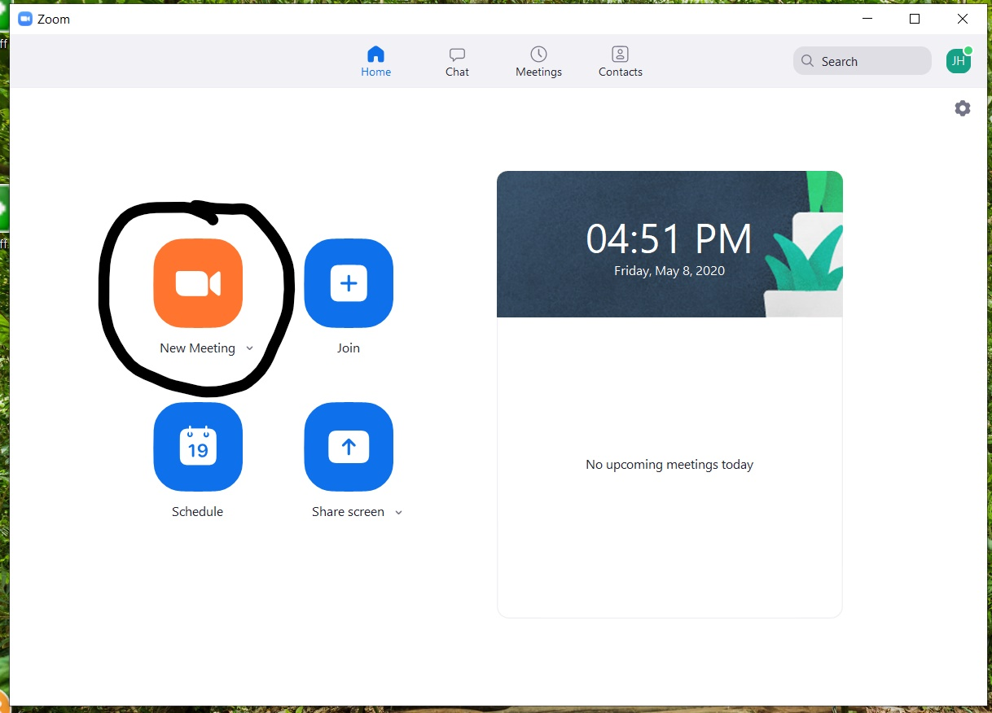

- This will take you right into the courtroom with your PMI.

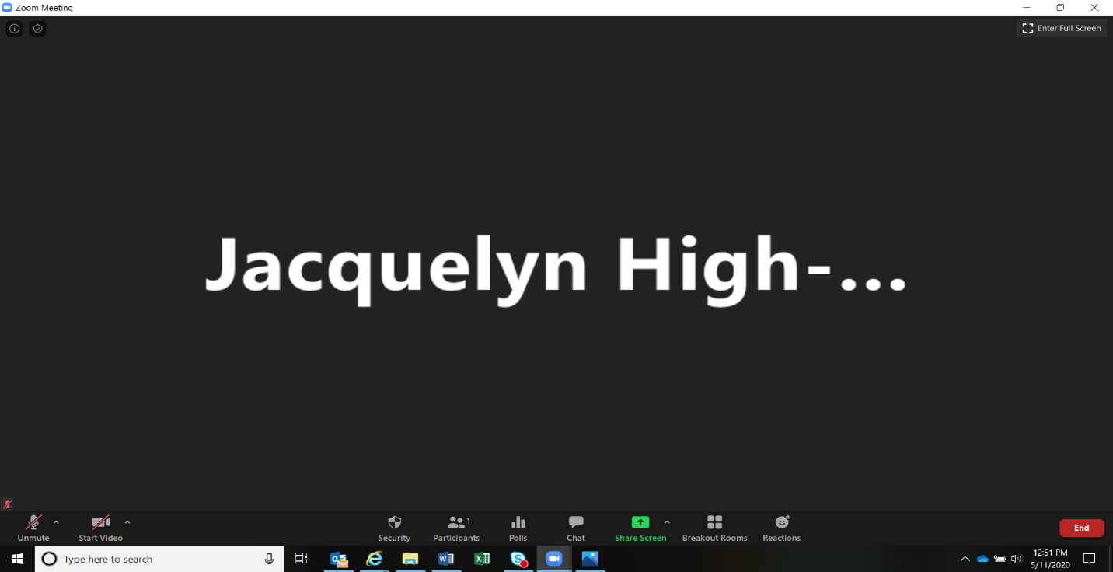

- Once in the courtroom, you can “Mute/Unmute” yourself or “Start or Stop Video”

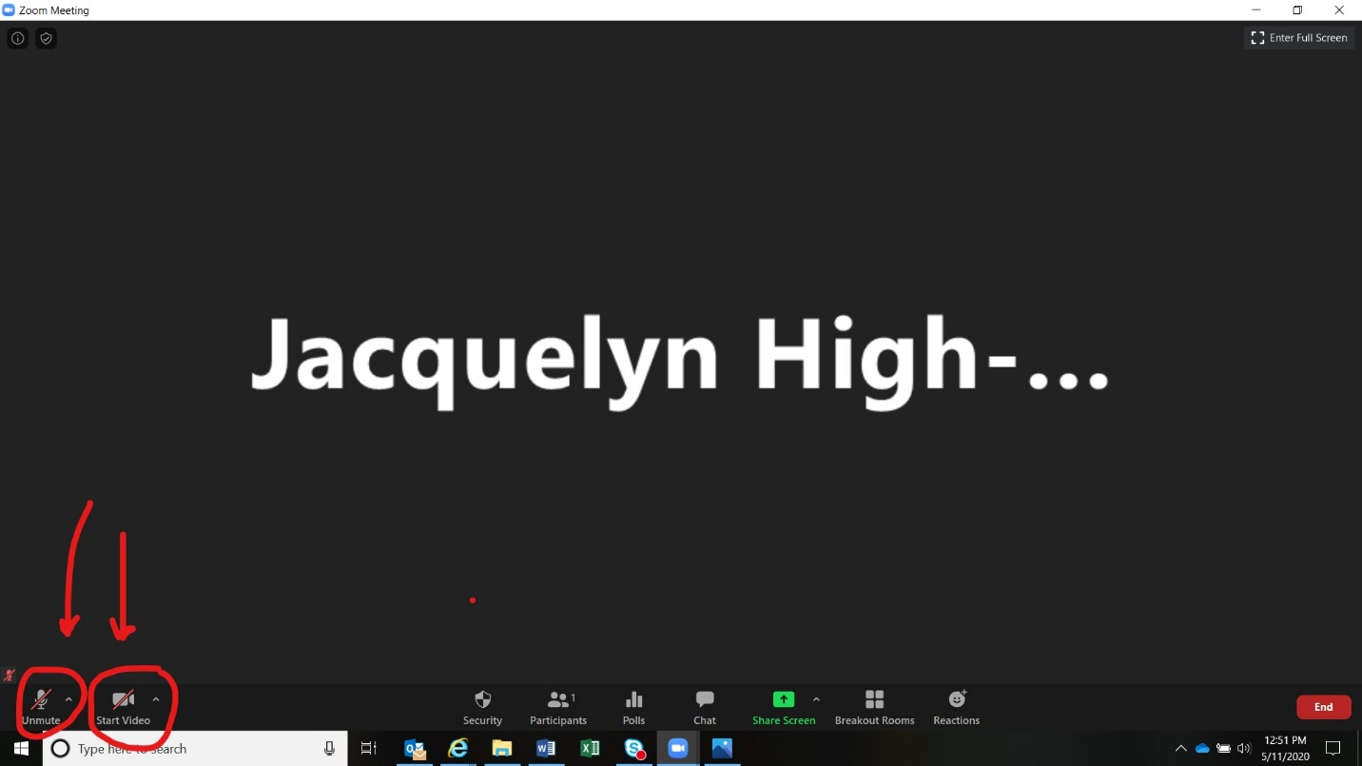

- Once you are in, please click on the “Participant” icon on the bottom

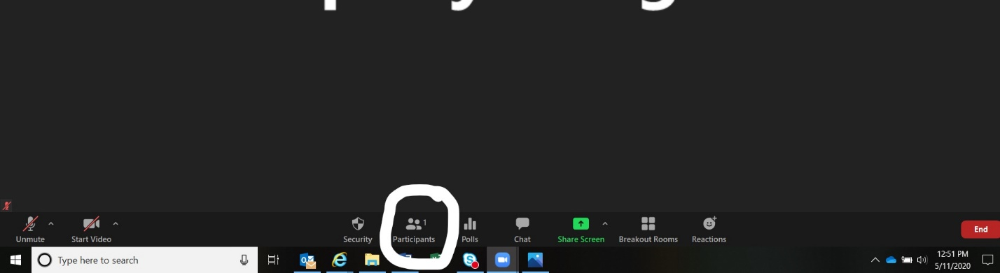

- This will show you all participants in the courtroom and in the waiting room

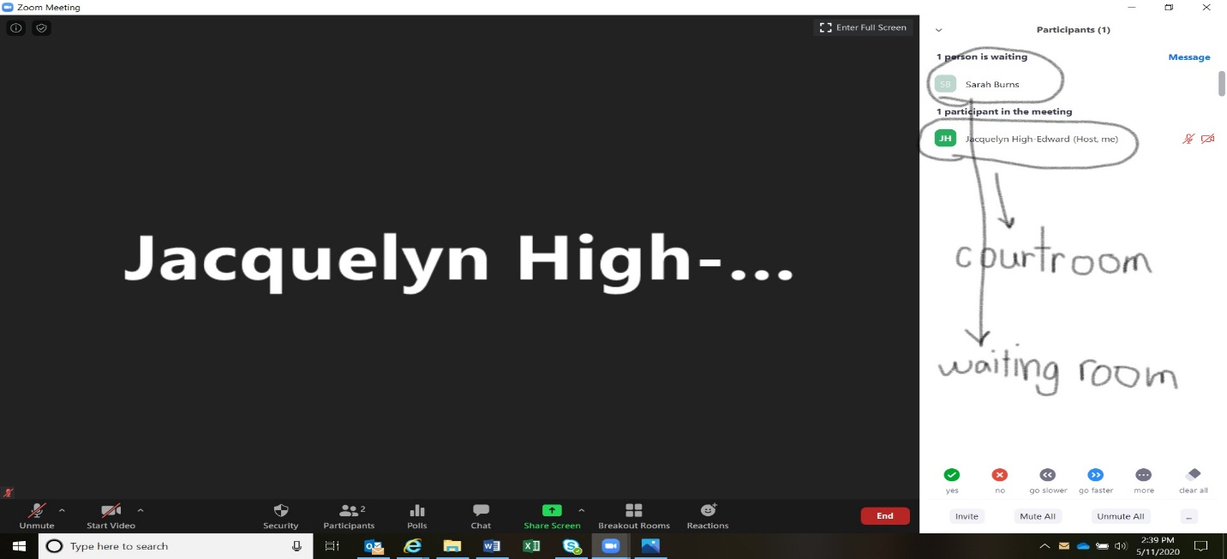

- All of our settings will put anyone signing into the courtroom with a PMI into a virtual waiting room.

- To admit people to the courtroom, go to the right side of their name – you will see the options “Admit” or “Remove”

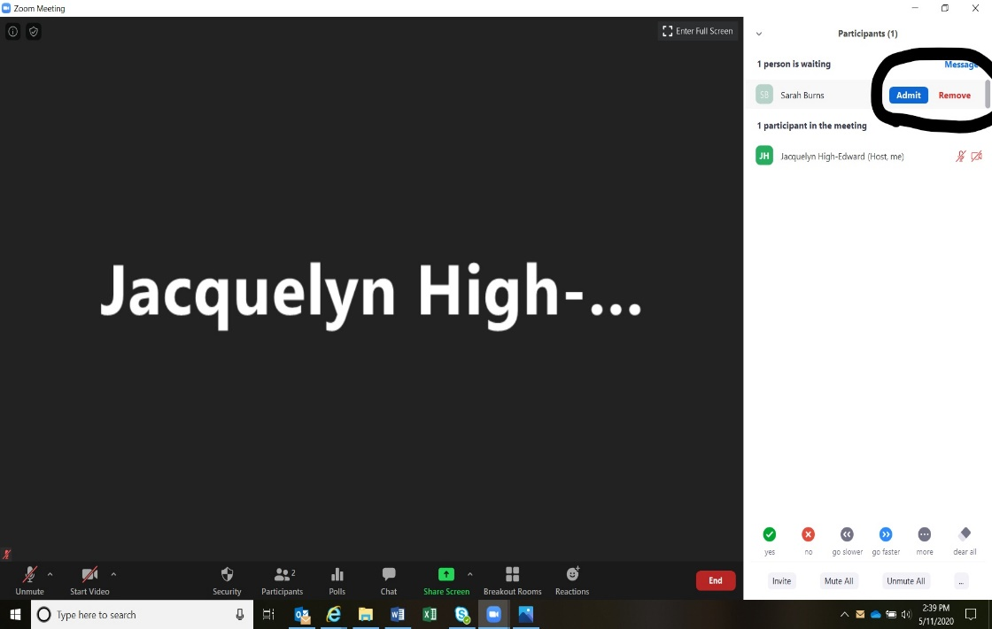

- Select, “Admit” and they will be placed in the courtroom

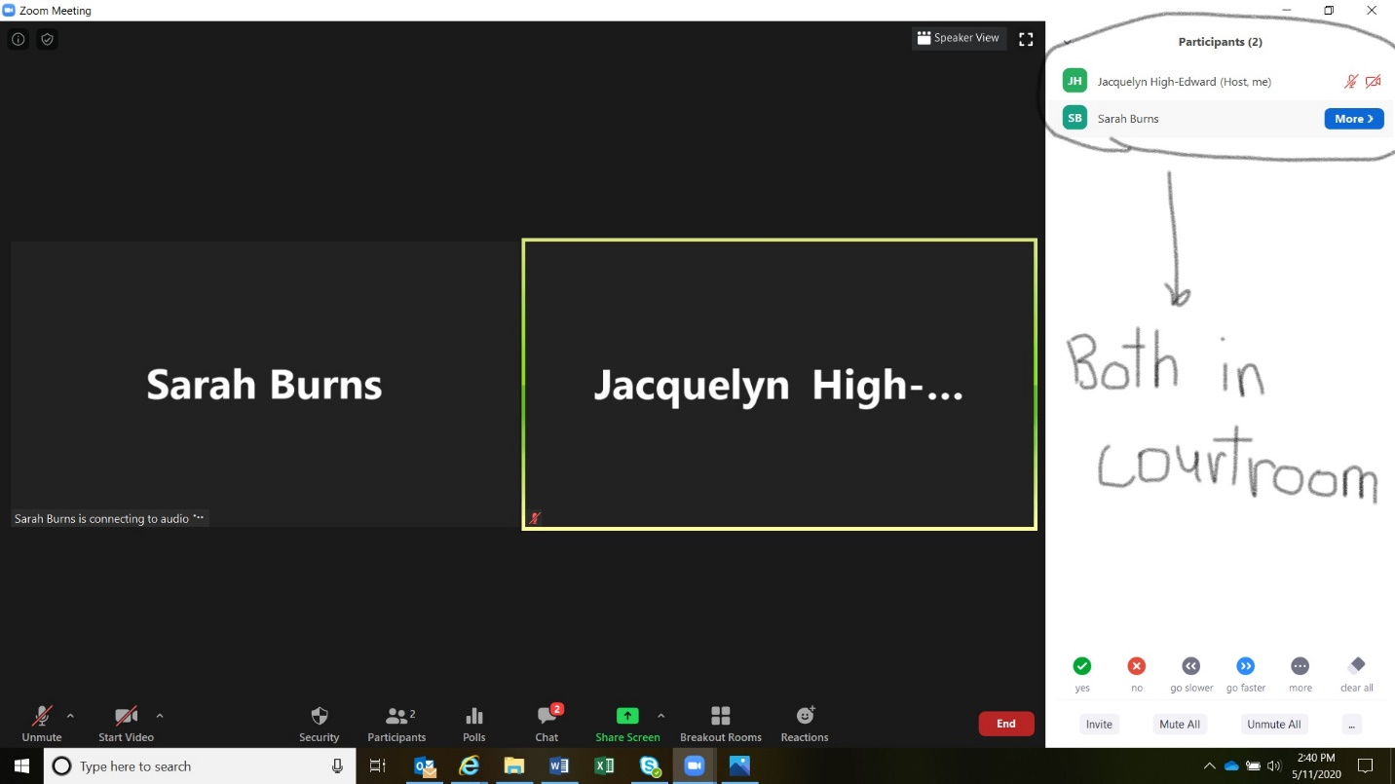

- Do this for everyone in the waiting room.
- You are now ready to start the hearing

Zoom features

co-hosting
- This allows you to designate other professionals to control the courtroom including:
  - Admitting people from the waiting room
  - Present documents
  - Muting participants
  - Removing people from the virtual hearing.
- Once someone is a co-host, they can do any of these options. You will need to set expectations on what they can and cannot do (for instance they can share screen and admit people from waiting room but not mute others or remove people from hearing).
- Instructions:
  - Go to the participant list
  - Go to the person you want to make a co-host (you can make as many people a co-host as you want). We recommend making all hearing participants co-hosts (attorneys and parties)
  - Go to the right of their name and select “More”
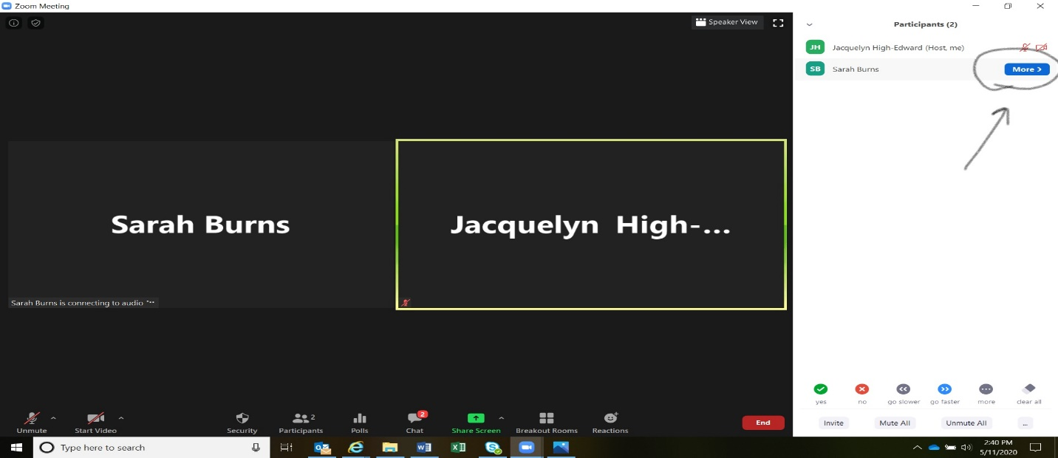

  - A dropdown menu will appear
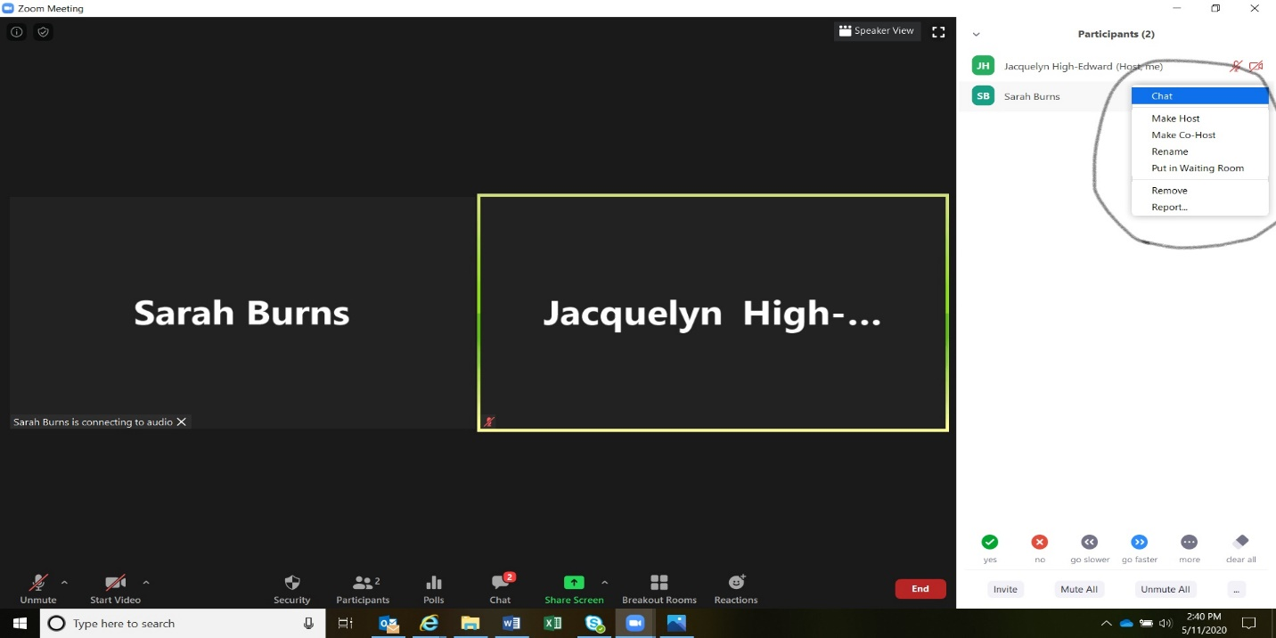

  - Select “Make Co-Host”
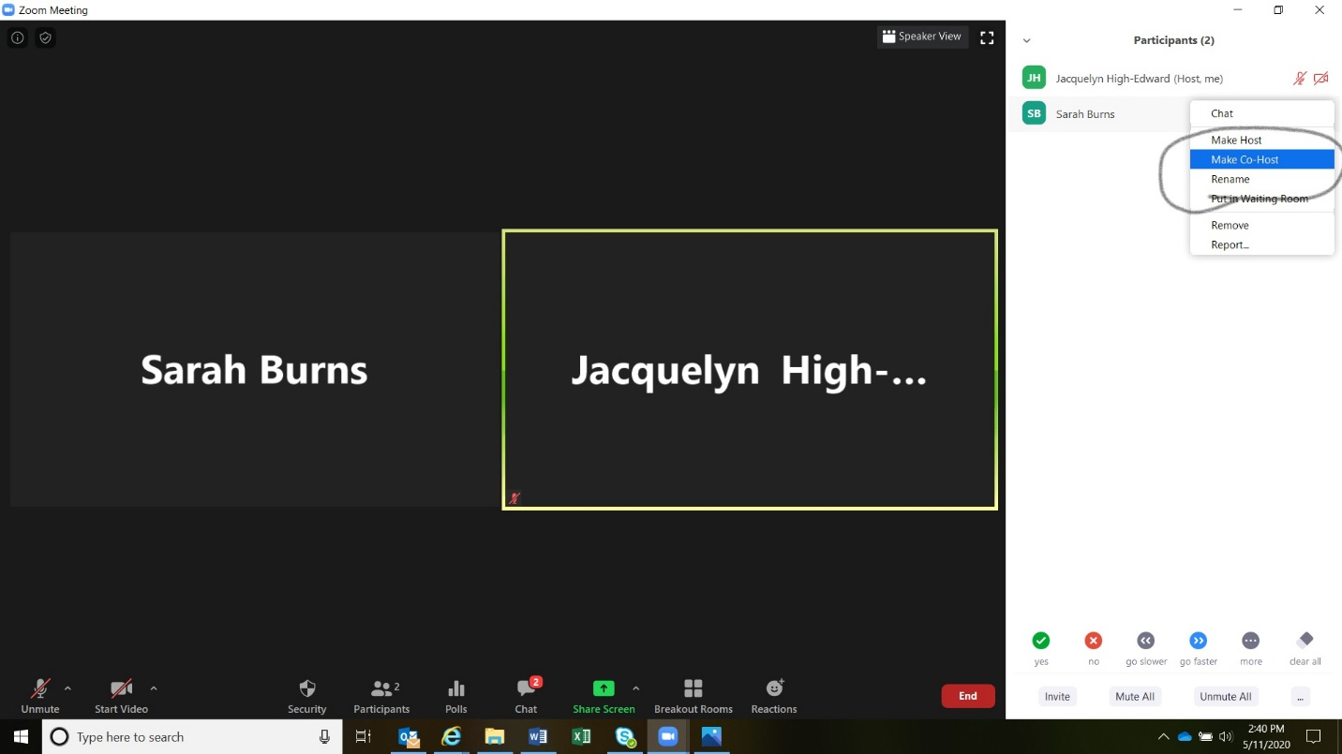

  - Confirm person as co-host
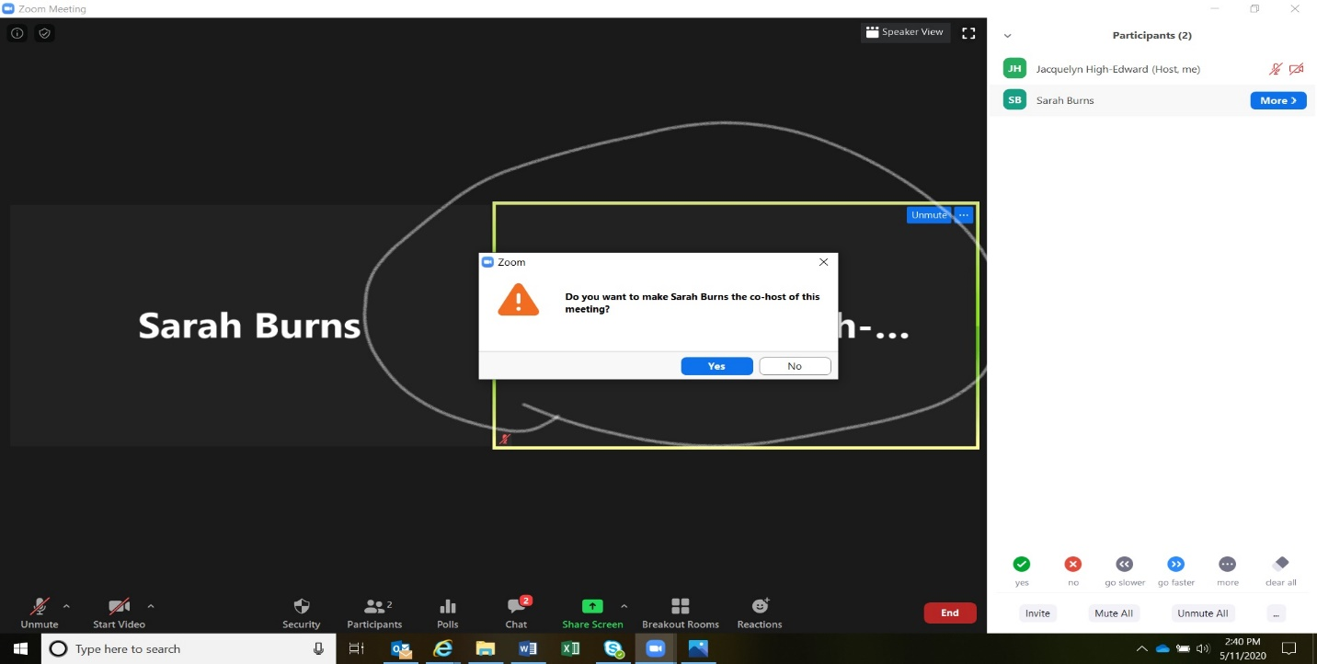
  - You can make some a co-host and remove them as co-host throughout the hearing
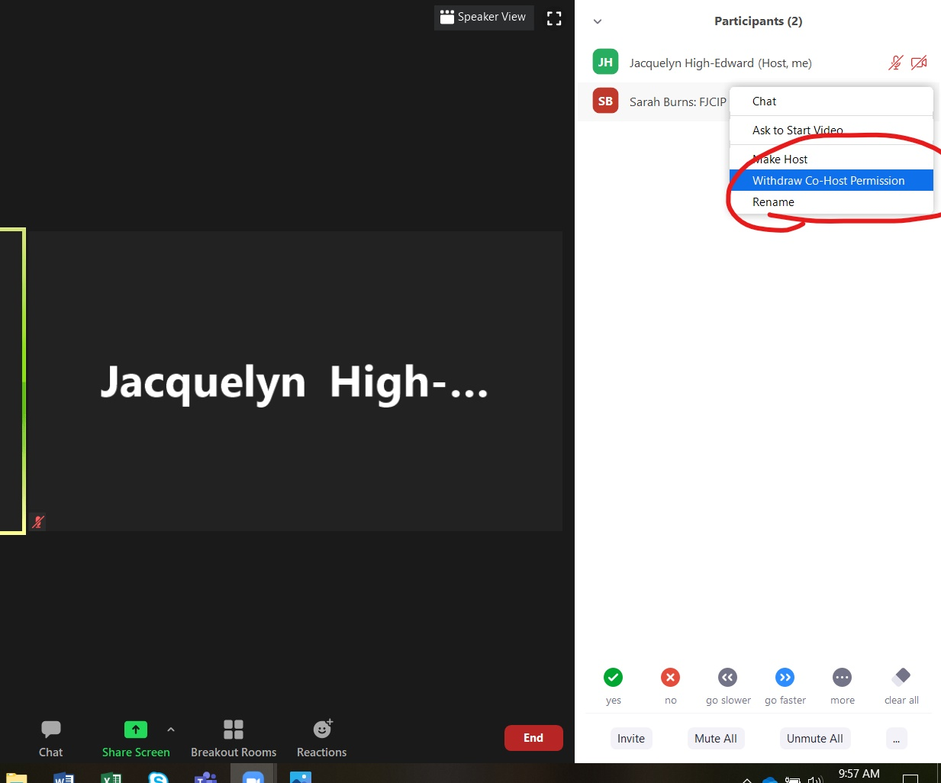
Private Chat:
- This is available for counsel to chat quickly with their client privately (similar to exchanging notes during argument). This should not occur when the client is testifying and should not occur between any other participants. Private chats cannot be read by anyone, including the host and co-host. Judicial officers should never privately chat with anyone except maybe the clerk in the case of an emergency
- Instructions:
  - Go to the “Chat” icon at the bottom of the screen.
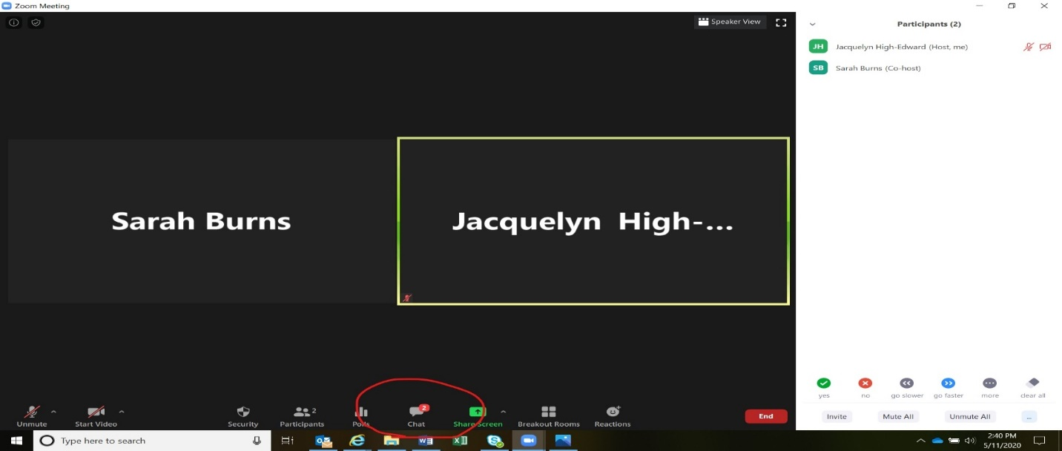

  - The “Chat” box will appear and you will see a dropdown menu
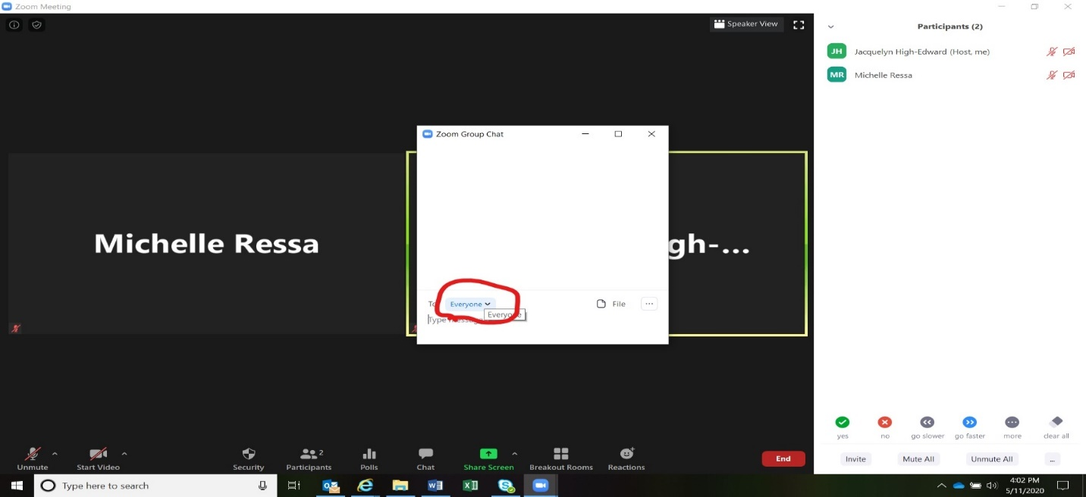

  - Select the individual you would like to have a private chat with
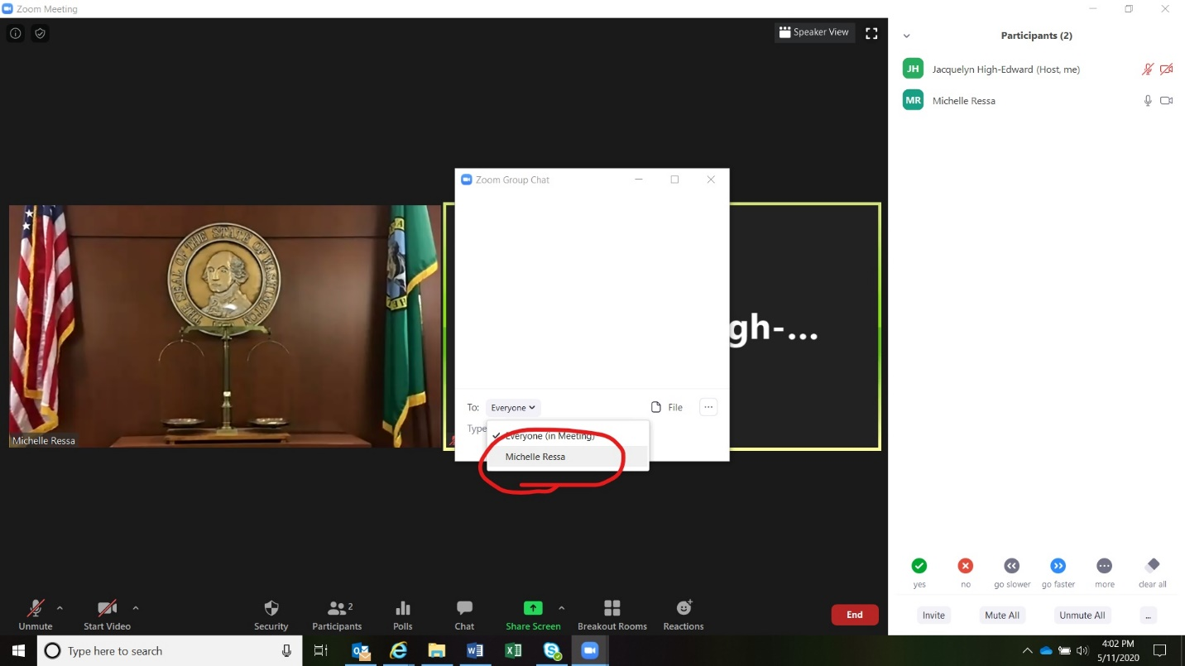
  - No other person in the hearing will be able to observe this private chat

SHARING SCREEN/ Presenting documents
- The court and co-hosts can present documents directly from their desktop
- Instructions:
  - The document you want to share needs to be open on your desk top
  - Select “Share Screen”
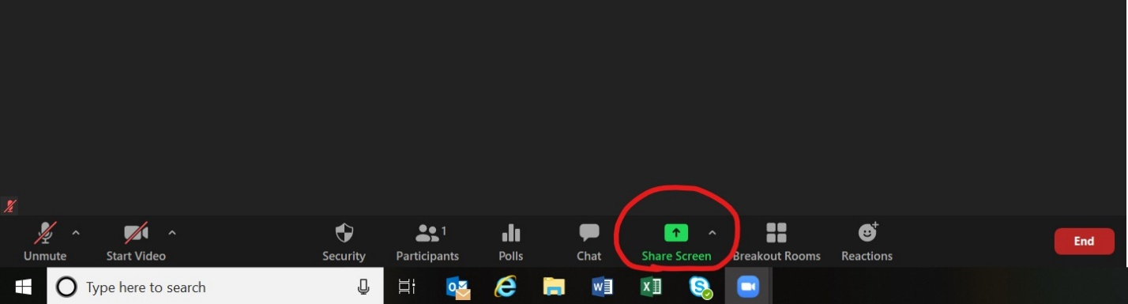
  - Our settings will (set by Sarah) will only allow hosts and co-hosts to share documents. This is a security setting that will prevent observers from showing inappropriate content through this function.
  - All of your open documents will come up (not viewable to anyone else)
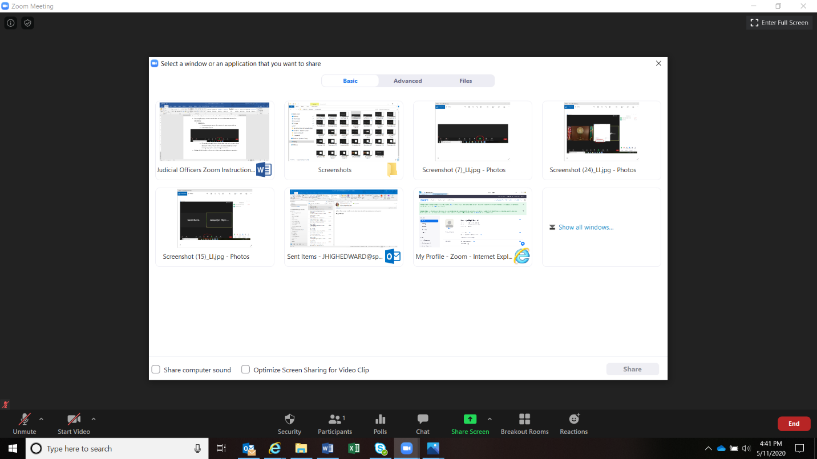

  - Select the document you want to share
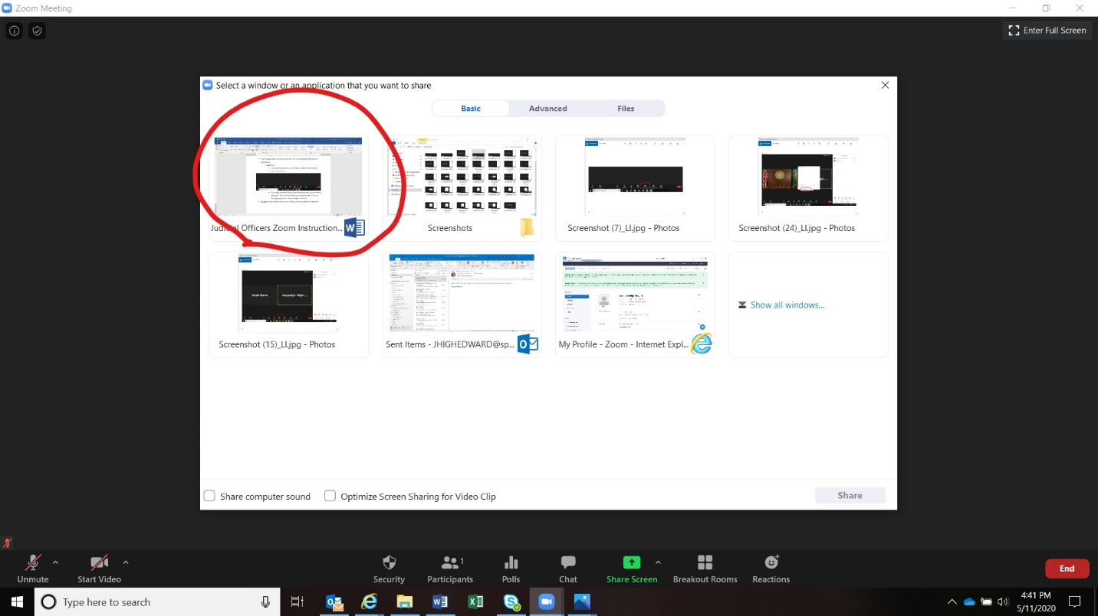
  - Click “Share”
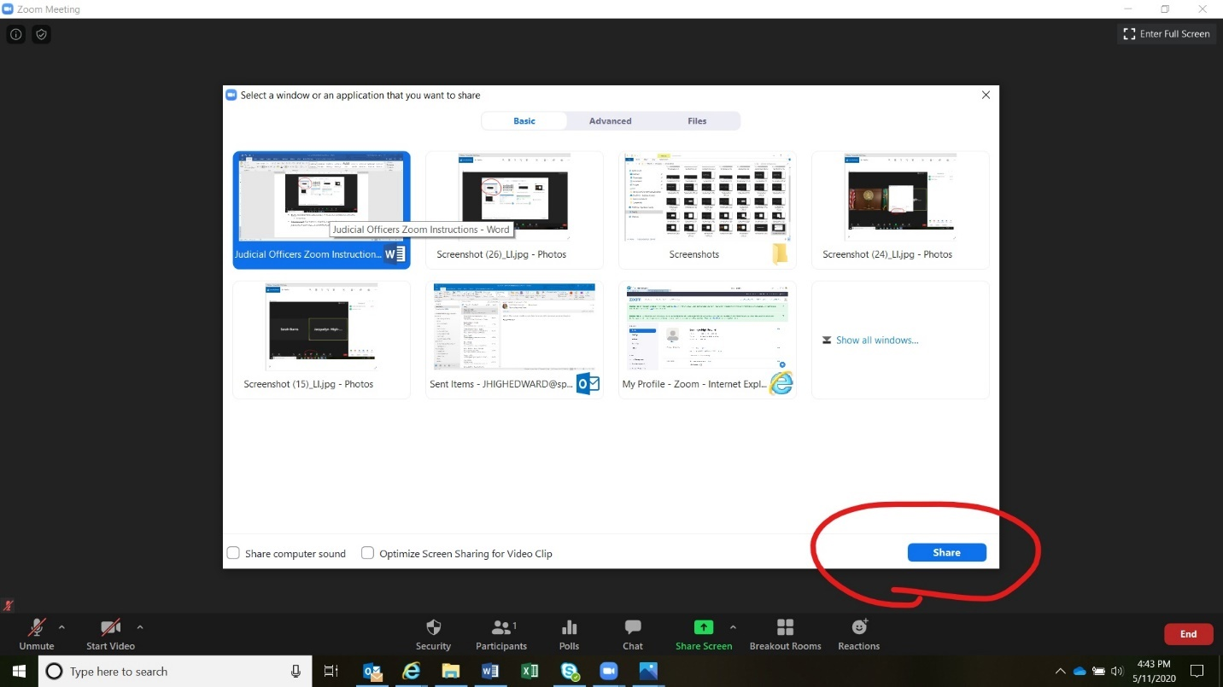

  - The document will be shared with the courtroom
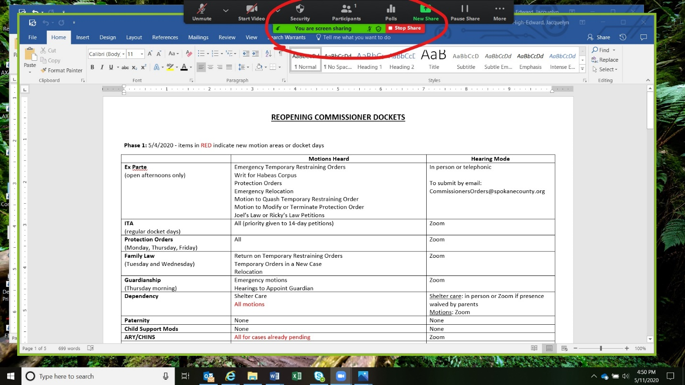

  - To stop sharing, simply select “Stop Share”
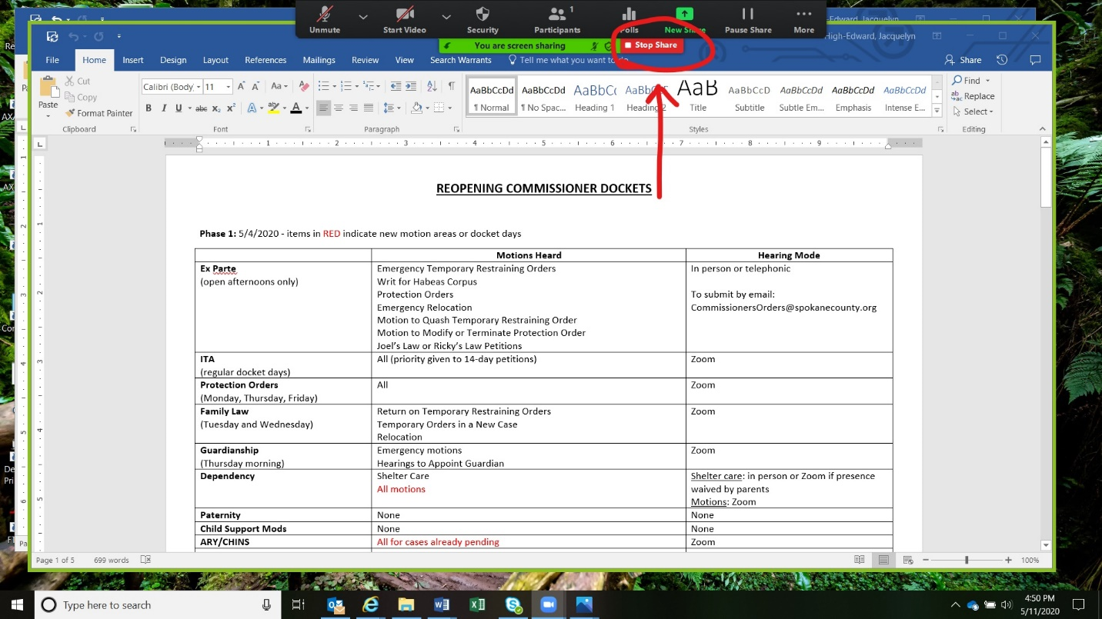

Breakout Rooms
- If a longer conversation is needed between counsel and client or between attorneys, the court can open a private breakout room
- Instructions:
  - Select “Breakout Rooms”
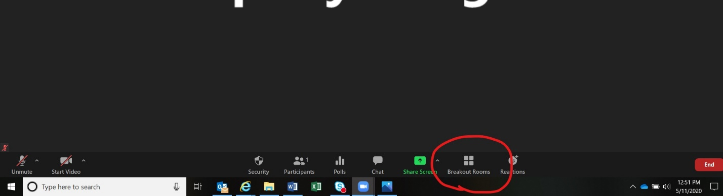
  - You will be asked how many rooms you want
  - Then select “Create Rooms”
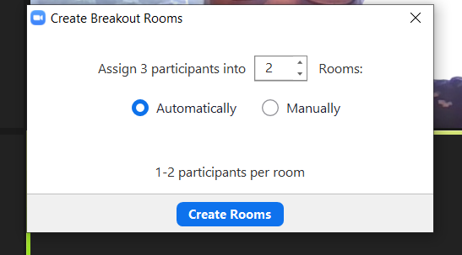

  - You will then be able to put individuals into particular rooms by hovering over the left side of their name
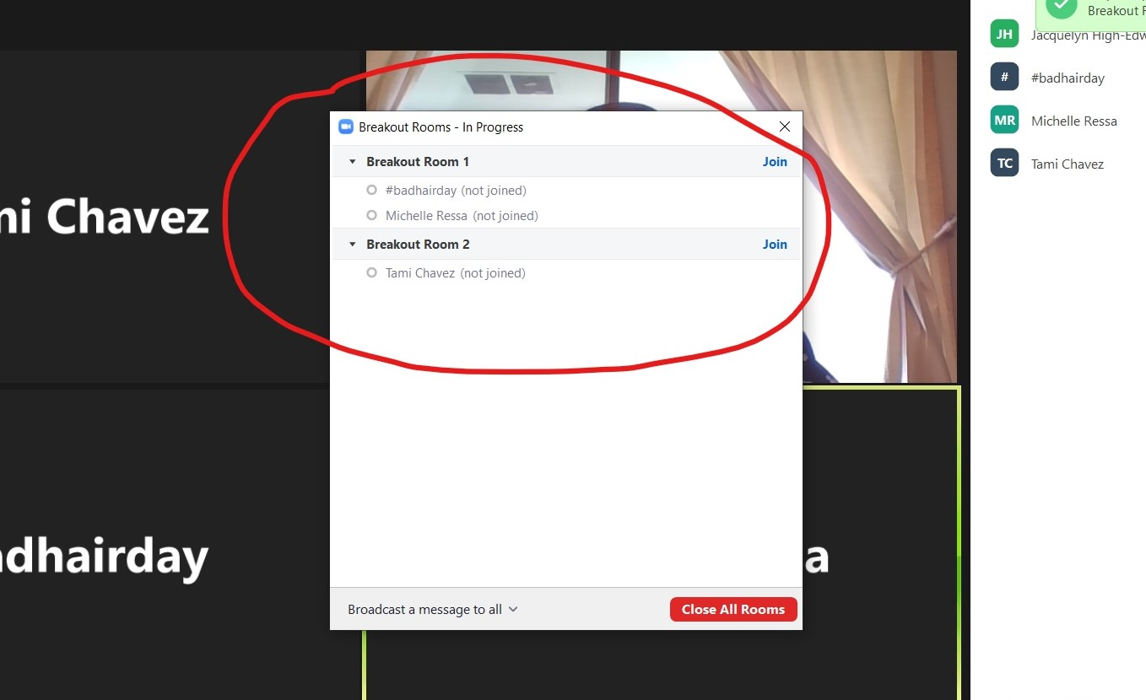
- Each person will then join the private breakout room and disappear from the Zoom hearing (only host left in hearing room)

- Our settings will allow participant to rejoin the meeting at their discretion. We can also close the breakout room.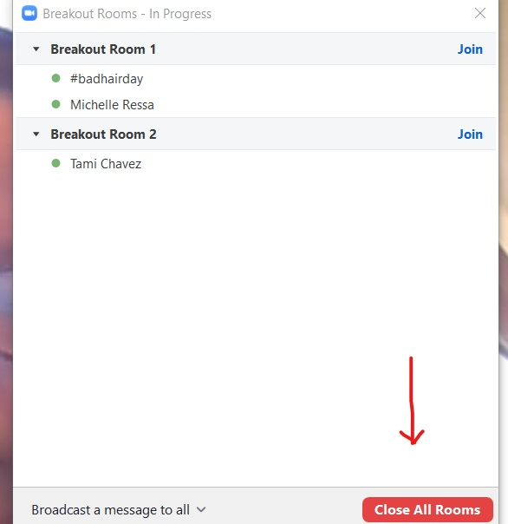
- When you close the breakout rooms, participants will get a message that the breakout room will close in 60 seconds.
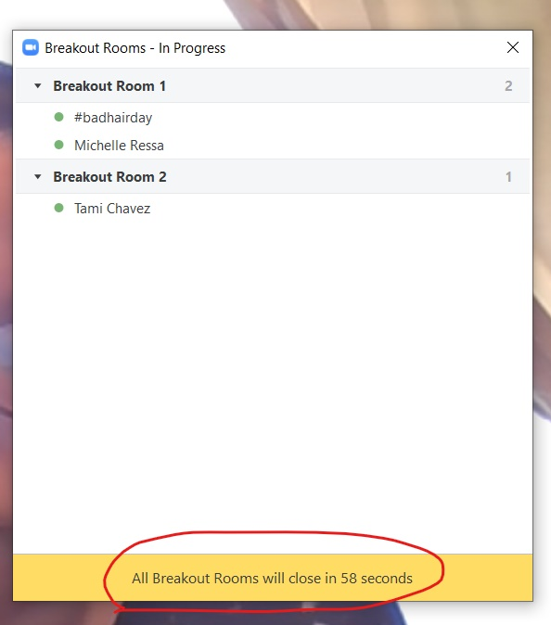
- Participants can rejoin by themselves or will be put back into the Zoom hearing when the 60 second time period ends.
Removing people
- While all co-hosts can remove participants, only the judicial officer will be allowed to do so
- Instructions
  - You can remove someone from the hearing from either the participant list or through the “Security” button along the bottom of your screen.
  - Participant List:
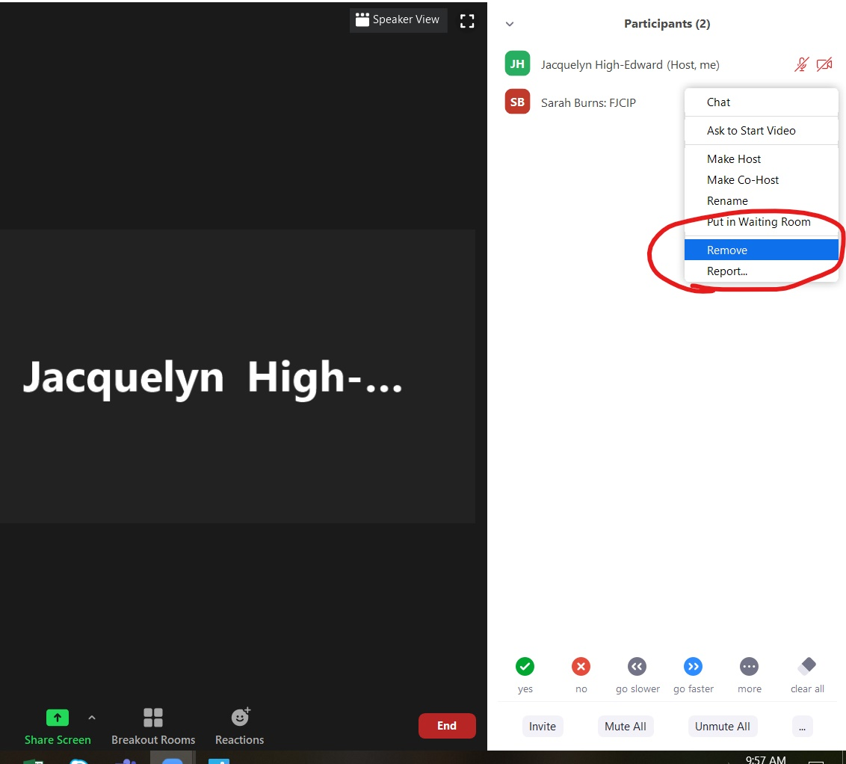

  - Security Button

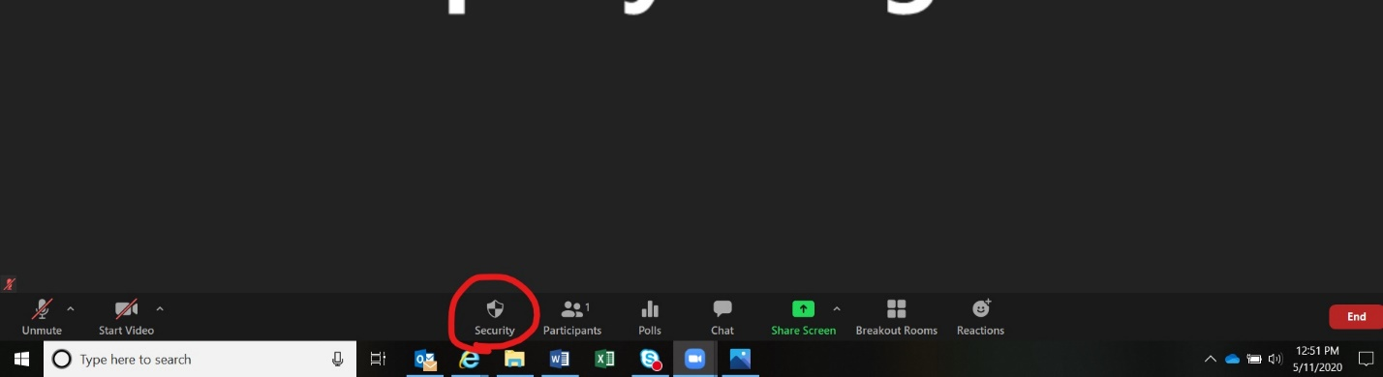

  - Confirm that you want to remove the individual
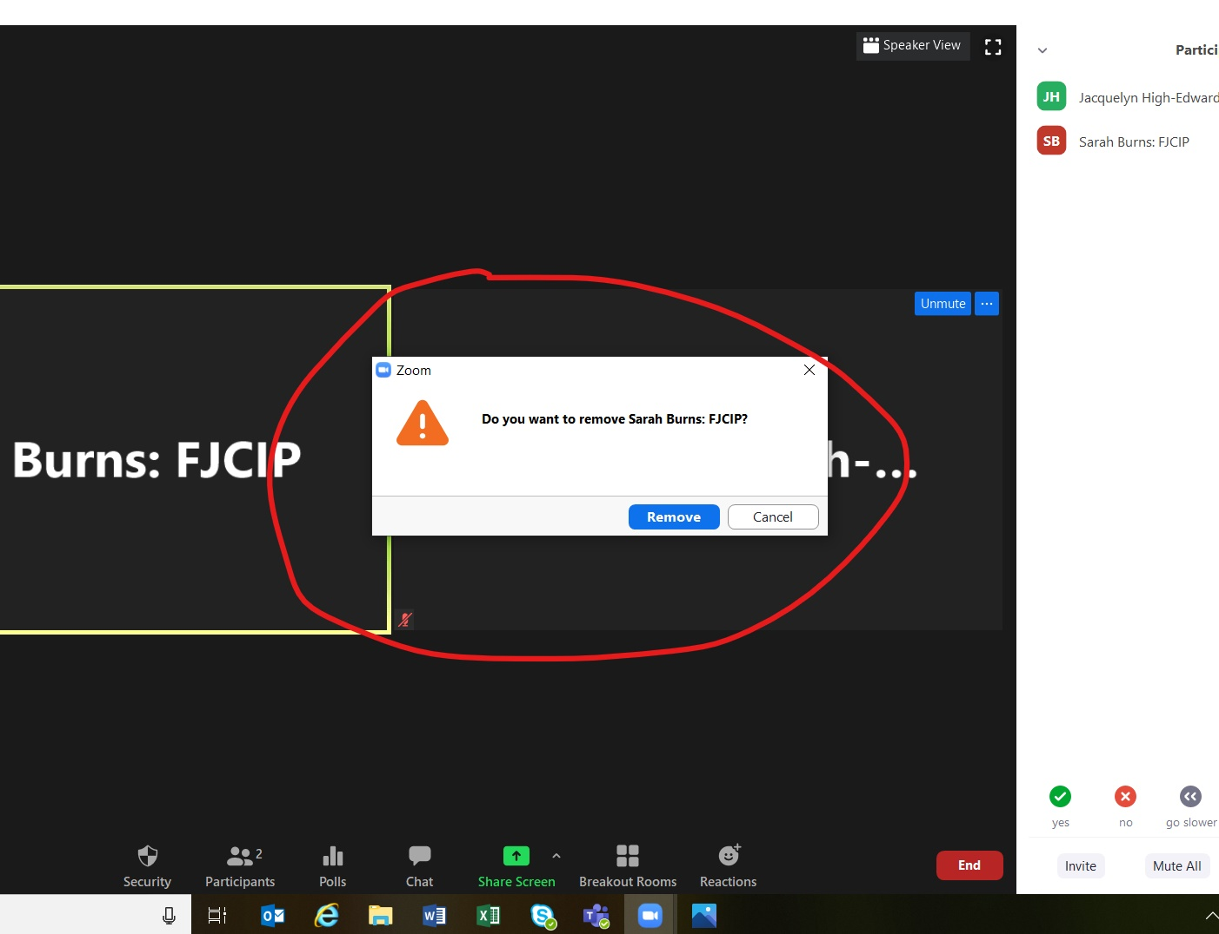

file share
- Our settings will only allow co-hosts to file share.
- Instructions:
  - Click on “Chat”
  - Click on “File”
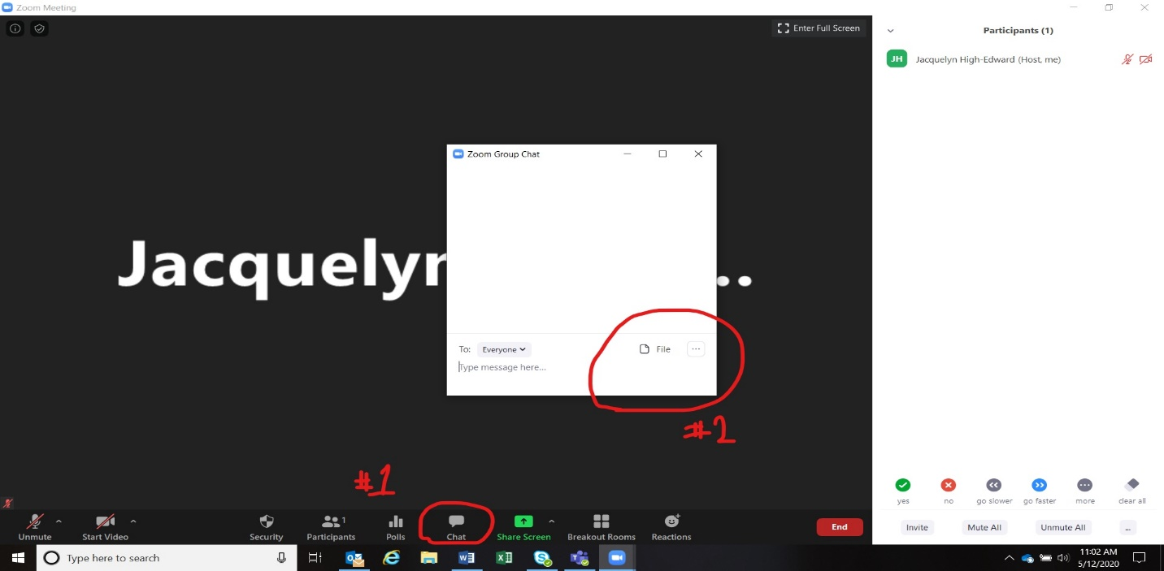
- Select type of file you want to share
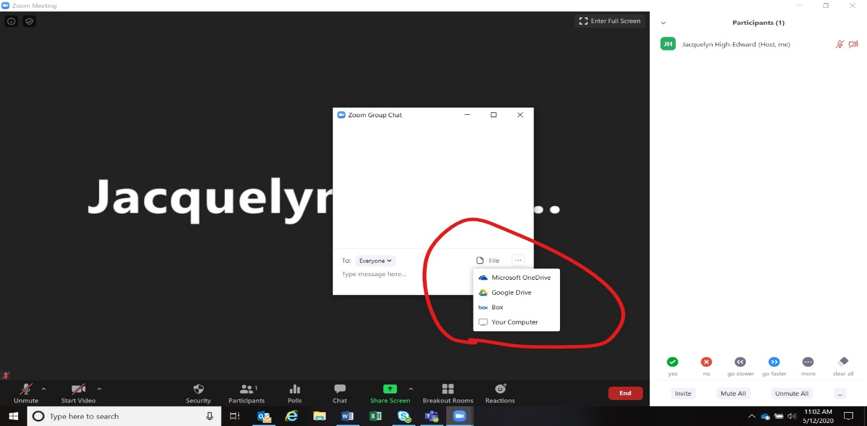

- Attach the file and it will be shared in the chat box
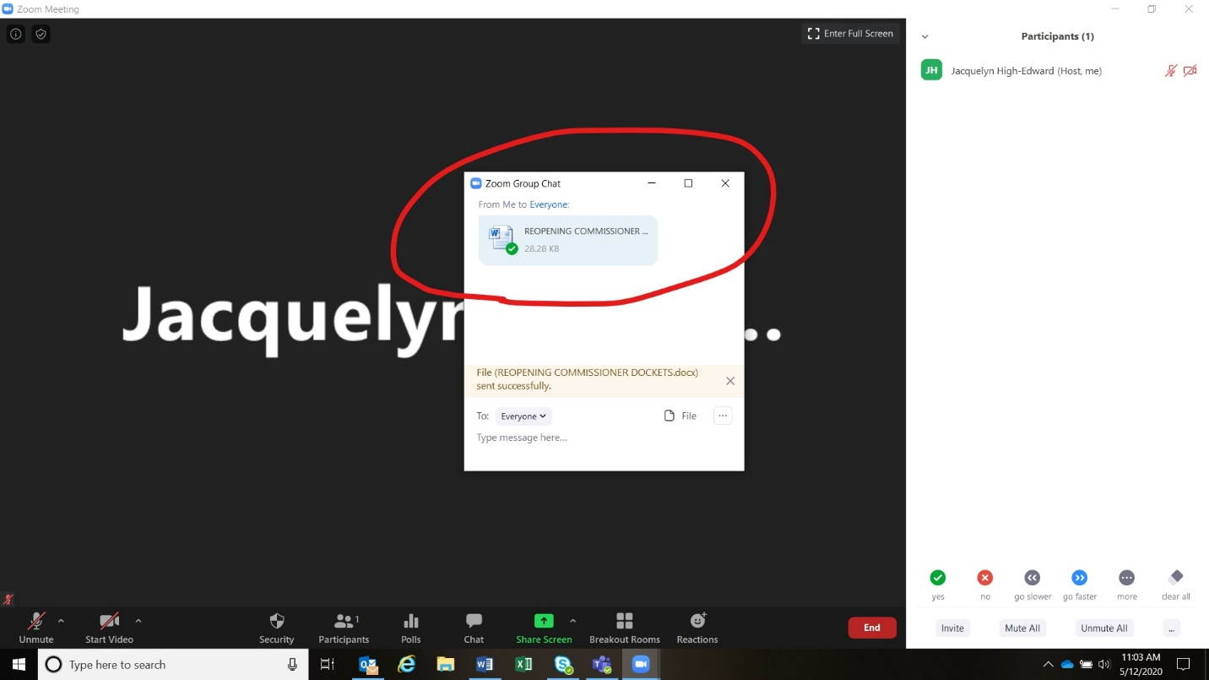

Muting
- While any co-host can mute participants, only the judicial officer will be allowed to do so during a meeting
- Instructions
  - Go the person you want to mute in the participant list. On the right side a mute button will appear. You can mute the participant from there.
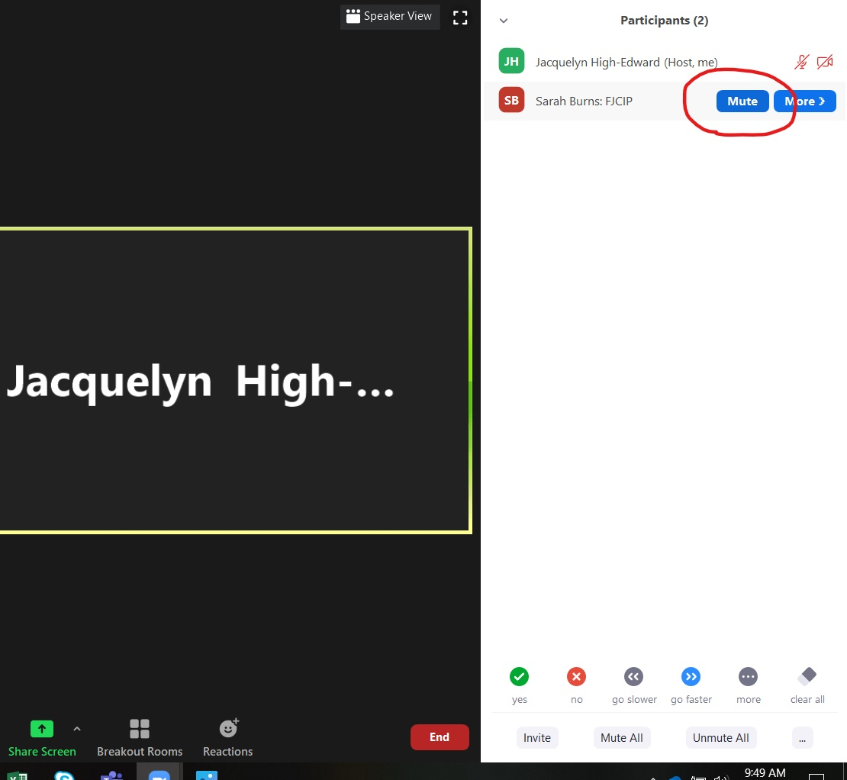
SAMPLE hearing script

- Log onto the virtual courtroom 10 minutes prior to the hearing time
- Admit participants and the public into the courtroom
- Make all hearing participants (attorneys, parties, GAL, etc.) co-hosts. This will allow them to do a private chat, put them into breakout rooms, and share a screen.
- Ensure all participants are present prior to starting the recording
- Sample Opening Script (after going on the record)
- Good Morning/Afternoon – we are on the record in the matter of _________.
- Participants in this matter are: ______________________________ and they are present via Zoom. We are conducting this hearing virtually.
- This technology is new to most of us and conducting hearings virtually can have its own issues.
  - Please do not panic if you experience technical difficulty. If you are able to alert the court to these difficulties, please do so immediately. We will stop the hearing and try to resolve your issues.
  - If the issues cannot be resolved, we will reschedule your hearing so that you can fully participate in it.
- As with in-person hearings, participants and observers are prohibited from recording these proceedings in any way. All hearings are being recorded by the court’s official court recorder and transcripts may be ordered from a certified court reporter.
- Communicating during a hearing:
  - There is a private chat feature which may only be utilized by attorneys and their clients during times the client is not testifying. This feature shall not be used to communicate with your client during testimony or for any other purpose.
  - If you need to confer with your client or opposing counsel, we have break out rooms available. Please request a recess and I will open a private breakout room for this conversation. Neither the court, nor any other participant or observer will have access to this breakout room. They are private and confidential.
- Public Access:
  - The public will be allowed access to these hearings unless a motion to close the hearing is made and granted. Public observers, like in-person court proceedings, will not be allowed to participate in the hearing.
  - Any member of the public who is distracting during the hearing will be warned and then, if the behavior continues, will be removed from the hearing.
- Instructions on how the hearing will proceed:
  - The hearing will begin with ___________________
  - Then ____________ will have an opportunity to respond
  - Then we will hear from _______________ and _______________.
  - I will ask each participant to mute their microphone unless it is your turn to speak or you have a legal objection. When an objection is made, everyone is to stop speaking and I will address the objection. Please wait until I call on you to speak. This will make sure we have a clean record and avoid confusion if more than one person is speaking.
  - Before I end the argument portion of this hearing, I will ensure that everyone has had an opportunity to speak and present their evidence.
  - Please do not interrupt while I am giving my ruling. I will ask if there are any questions once I am done.
  - If you get disconnected or can no longer hear the proceedings, please contact your attorney or the court clerk at __________. We will pause the hearing and wait until you are reconnected.
- Are there any questions or items we need to address before we start our hearing?
  - Check with each individual participant to ensure everyone has an opportunity

Considerations for Virtual Hearings

Virtual hearings have similar considerations as appearing in person in a courtroom
- Dress professional- when possible, wear your robe
- Display your name and title using the Zoom profile feature
- Avoid moving your video or quick movements
- Have an alternative plan for appearing if you have technology problems (all Zoom conferences have call in capabilities)
- Be prepared to unmute and speak as needed
- Be prepared to manage the participants in the waiting room and the hearing
- If you leave the hearing, mute your audio and video

Although hearings are open to the public, sensitive, and sometimes traumatic, information is shared.
- Limit hearing exposure to people in your environment who are not part of the hearing, by choosing a quiet, confidential space to take part in the hearing when possible
- Only share files during the hearing with the professionals who need the file to do their work
- Use a virtual courtroom background for hearings
- Have court professionals provide instructions in advance for attending virtual hearings.
  - Additional direct instruction for logging into hearings, accessing WIFI/internet connections, creating a quiet space for appearing etc. should be encouraged.
  - If public participants are well prepared for virtual hearings, they will be more likely to remain calm and in the thinking part of their brain for their hearing. It will also make the virtual hearing process more efficient for the court and professionals.

