***Directions:****Read each sentence carefully. For each sentence, please think about how you are in most situations. Using the scale shown below, select the number that best describes YOU. There are no right or wrong answers.*

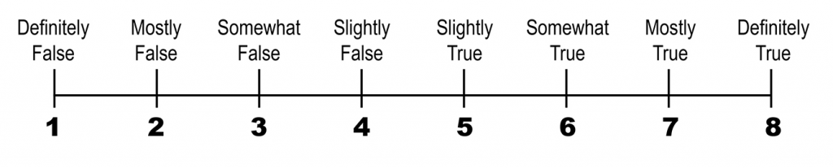_____ 1. I can think of many ways to get out of a jam.

_____ 2. I energetically pursue my goals.

_____ 3. There are a lot of ways around any problem.

_____ 4. I can think of many ways to get the things in life that are most important to me.

_____ 5. Even when others get discouraged, I know I can find a way to solve the problem.

_____ 6. My past experiences have prepared me well for my future.

_____ 7. I’ve been pretty successful in life.

_____ 8. I meet the goals that I set for myself.

**Agency** Score __________ (Add items 2, 6, 7 and 8)

**Pathways** Score __________ (Add items 1, 3, 4 and 5)

**Total HOPE Score** __________ (Agency Score + Pathway Score)